Grant Agreement for Erasmus+ traineeship
2022-2023
PhD

The Sending / Home Institution
Name institution: | Vrije Universiteit Amsterdam
Erasmus code institution: | NL AMSTERD02
Address: | De Boelelaan 1105, 0E-68, 1081 HV Amsterdam, The Netherlands
Called hereafter "the institution", represented for the purposes of signature of this agreement by Job Mulder, Erasmus+ Grant Coordinator of the one part, and:

The Trainee
Employee number:
Family name(s):
First name(s):
Date of birth (dd/mm/yyyy):
Sex:
Nationality:
E-mail:
Payment details
Bank accountholder:
Bank account number:
Address accountholder:
Traineeship details
Study cycle (PhD/other):
Field of Education/ISCED 2013:
Graduate school:
Host/receiving institution:
Erasmus code (if university) :
Legal name:
Legal address:
Telephone:
Website:
Country:
Name sector:
Department/unit:
Size of enterprise:
First working day [dd/mm/yyyy]:
Last working day [dd/mm/yyyy]:
Number of recognized credits (ECTS):
Language competence of the trainee
Main language (e.g., English, Spanish, other):
The level of language competence that the trainee already has or agrees to acquire by the start of the mobility period is: | A1 A2  B1 B2  C1 C2 Native speaker
OLS language tests in: | English  national language of host country  not applicable: native speaker of language of work
Mobility barriers
Please thick the box(es) that fit your circumstances, according to your opinion. More than one answer is possible. This information is solely used anonymously, to gather statistics to improve the Erasmus programme, and making it an inclusive programme for all!
- Disability: This includes physical, mental, intellectual or sensory impairments which, due to various barriers, may hinder someone’s full and effective participation in the programme.
- Health problems: Barriers may result from health issues including severe illnesses, chronic diseases, or any other physical or mental health-related situation that prevents from participating in the programme.
- Barriers linked to the educational system: Individuals struggling to perform in education and training systems for various reasons. Educational difficulties can be linked to personal circumstances, but they mostly result from the structural limitations within the educational system. For instance, that the study programme does not provide sufficient elective space making it difficult for the student to participate in the programme, or that the educational system does not fully take into account the individual’s particular needs.
- Cultural differences during the mobility: Being exposed to foreign languages and cultural differences when taking part in an international mobility programme may be a barrier or it can limit the benefits from their participation. It may even prevent potential participants from applying for support through the programme, thereby representing an entry barrier. Cultural differences can be perceived as a barrier to participate by people from any background, and can particularly affect people with fewer opportunities, especially people with a migrant or refugee background, people belonging to a national or ethnic minority, sign language users, people with linguistic adaptation and cultural inclusion difficulties, etc.
- Social barriers: Social barriers can stem from family circumstances, for instance being the first in the family to attend higher education or being a parent (especially a single parent), a caregiver, a breadwinner, or an orphan, or having lived or currently living in institutional care. Other social barriers can stem from social marginalization or social adjustment difficulties such as limited social competences, anti-social or high-risk behaviours, (former) offenders, (former) drug or alcohol abusers.
- Economic barriers: Economic disadvantages like a low standard of living, low income, students who need to work to support themselves, dependence on the social welfare system, in long-term unemployment, precarious situations or poverty, being homeless, in debt or with financial problems, etc., may represent a barrier to participate. Barriers may also stem from difficulties to transfer or continue to receive any (economic) support services during the participants time abroad.
- Barriers linked to discrimination: Barriers can occur because of discriminations linked to gender, age, ethnicity, religion, beliefs, sexual orientation, disability, or as a result of the intersection between two or more of the mentioned barriers.
- Geographical barriers: Geographical barriers can be experienced by people from remote or rural areas, people living in small islands or in peripheral regions, people from urban problem zones, people from less serviced areas (limited public transport, poor facilities).
- None of the above.
Inclusion top-up
- The following question only applies to applicants that ticked box 1 ‘disability’ and/or box 2 ‘health problems’ regarding the mobility barriers.
Would you like to apply for an Erasmus+ inclusion top-up grant? | Yes / No
If yes, please include a statement from a health care provider or organization when sending your Grant Agreement to erasmus@vu.nl
- Please note: the Erasmus+ inclusion top- up in case of disability or health problems cannot be combined with the inclusion top-up in case of economic barriers (it is the same top-up).
- Students eligible for an Erasmus inclusion top-up grant will receive an additional top-up for individual support of 250 euro per month.

- The following question only applies to applicants that ticked box 6 ‘economic barriers’ regarding the mobility barriers.
Do you receive a supplementary grant from DUO in 2021? | Yes / No
If yes, would you like to apply for an Erasmus+ inclusion top-up grant? | Yes / No
If yes, please include the official statement from DUO with the confirmation of being awarded the supplementary grant for the calendar year 2022 when sending in the Grant Agreement to erasmus@vu.nl
- Please note: the Erasmus+ inclusion top- up in case of disability or health problems cannot be combined with the inclusion top-up in case of economic barriers (it is the same top-up).
- Students eligible for an Erasmus inclusion top-up grant will receive an additional top-up for individual support of 250 euro per month.
Green Travel top-up
What is your main means of transportation for the first and last international travel day to and from your host country? | Bus  Train  Motorbike | Car  Ship  Plane | Other_____  Carpooling  Bike
Have you travelled by train, bus, bike, shared car (carpooling) or any other sustainable means of transportation? | Yes / No
Is yes, would you like to apply for the Green Travel individual support top-up of €50? | Yes / No
- If yes, please include the ‘Statement Green Travel’ when sending in the Grant Agreement to erasmus@vu.nl
If yes, fill out direct distance in kilometres (KM): | ________ (Use Distance Calculator | Erasmus+ (europa.eu))
Do you need additional travel days for your Green Travel? | Yes / No
If yes, how many days? | ________ days (range 0 – 4 days)
Registration, scholarship application and Covid-19 travel policy
- I agree with the Covid-19 VU travel policy (see last page of this agreement): |  |  |  | Yes / No
- I will send erasmus@vu.nl a screenshot of the travel advice on the day of my journey: |  |  |  | Yes / No

To be completed by VU International Office:
Erasmus grant
The participant shall receive (tick box): |  | a) a financial support from Erasmus+ EU funds: | For ___ days
 |  |  | €
 |  | b) a zero-grant
 |  | c) a financial support from Erasmus+ EU funds combined with zero-grant | For ___days
 |  |  | €
Additional support / grant
Total amount includes: |  | Erasmus Inclusion top-up grant | €
 |  | Erasmus Inclusion individual Support | €
 |  | Green Travel individual support top-up (€ 50) | €
 |  | Additional Green Travel days | €
 |  | Special needs support | €
Total amount
Based on the data provided, your provisional calculated Erasmus grant is: |  |  | €
This agreement must be signed on page 10.

The Grant Agreement
Called hereafter “the participant” of the other part, have agreed the Special Conditions and Annexes below which form an integral part of this agreement ("the agreement"):

Annex I General Conditions
Annex II Erasmus Student Charter
Annex III COVID-19 VU Erasmus+ travel policy
SPECIAL CONDITIONS
The terms set out in the Special Conditions shall take precedence over those set out in the annexes
ARTICLE 1 – SUBJECT MATTER OF THE AGREEMENT
1.1 | The Vrije Universiteit Amsterdam shall provide support to the participant for undertaking a mobility activity for traineeship under the Erasmus+ Programme.
1.2 | The participant accepts the financial support in the amount specified in article 3.1 and undertakes to carry out the mobility activity for traineeship as described in Annex I.
1.3 | Amendments to the agreement shall be requested and agreed by both parties through a formal notification by letter or by electronic message.
ARTICLE 2 – ENTRY INTO FORCE AND DURATION OF MOBILITY
2.1 | The agreement shall enter into force on the date when the last party of the two parties signs the agreement.
2.2 | The mobility period shall start on the start date at the earliest and end on the end date at the latest (see page 1). The start date of the mobility period shall be the first day that the participant needs to be present at the receiving organisation or the first day of language course attendance outside the receiving organisation. The end date of the period abroad shall be the last day the participant needs to be present at the receiving organisation.
2.3 | The participant shall receive a financial support from EU funds for the number of days mentioned on page 2.
2.4 | The total duration of the mobility period, including previous participation in the Lifelong Learning Programme Erasmus sub-programme, shall not exceed 12 months for a study cycle for long-term mobility.
2.5 | The participant may submit a request concerning the extension of the mobility period within the limit set out in article 2.4. If the organisation agrees to extend the duration of the mobility period, the agreement shall be amended accordingly.
2.6 | The certificate of Arrival and Departure shall provide the confirmed start and end dates of duration of the mobility period.
ARTICLE 3 – FINANCIAL SUPPORT
3.1 | The certificate of Arrival and Departure shall provide the confirmed start and end dates of duration of the mobility period.
3.2 | For long-term mobility the final amount for the mobility period shall be determined by multiplying the number of days/months of the mobility specified on the certificate of Arrival and Departure (Learning agreement, part 3) with the rate applicable per day/month for the receiving country concerned. In the case of incomplete months, the financial support is calculated by multiplying the number of days in the incomplete month with 1/30 of the unit cost per month.
3.3 | The reimbursement of costs incurred in connection with special needs, when applicable, shall be based on the supporting documents provided by the participant.
3.4 | The financial support may not be used to cover similar costs already funded by Union funds.
3.5 | Notwithstanding article 3.4, the grant is compatible with any other source of funding including revenue that the participant could receive working beyond its traineeship as long as he or she carries the activities foreseen in Annex I.
3.6 | The financial support or part thereof shall be repaid if the participant does not comply with the terms of the agreement. However, reimbursement shall not be requested when the participant has been prevented from completing his/her mobility activities as described in Annex I due to force majeure. Such cases shall be reported by the sending institution and accepted by the NA.
The financial support for the long-term mobility period has an amount of € 510, € 450, or € 390 per month, depending on location (see below):
Country group |  | Receiving country |  |  |  | Amount per month | Amount per day
Group 1: Countries with higher living costs |  | Denmark, Finland, Ireland, Iceland, Luxembourg, Liechtenstein, Norway, Sweden |  |  |  | € 510 | € 17
Group 2: Countries with medium living costs |  | Austria, Belgium, Germany, Cyprus, France, Greece, Italy, Malta, Portugal, Spain |  |  |  | € 450 | € 15
Group 3: Countries with lower living costs |  | Bulgaria, Croatia, Estonia, Hungary, Czech Republic, Latvia, Lithuania, Poland, Turkey, Slovenia, Romania, Slovakia, North Macedonia, Serbia |  |  |  | € 390 | € 13
ARTICLE 4 – PAYMENT ARRANGEMENTS
4.1 | Before departure a pre- financing payment shall be made to the participant representing 70% of the amount specified in Article 3. In case the participant did not provide the supporting documents in time according to the sending institution timeline, a later payment of the pre-financing can be exceptionally accepted.
4.2 | If the payment under article 4.1 is lower than 100% of the maximum grant amount, the submission of the on-line EU survey, 2nd language test and complete learning agreement shall be considered as the participant's request for payment of the balance of the financial support. The institution shall have 45 calendar days to make the balance payment or to issue a recovery order in case a reimbursement is due.
ARTICLE 5 – INSURANCE
5.1 | The participant shall have adequate insurance coverage. [Please, read the articles below carefully, and make sure that you are adequately insured when you go on your study exchange.]  Acknowledgement that health insurance coverage has been organised shall be included in this agreement. Usually, basic coverage is provided by the national health insurance of the participant as well during his/her stay in another EU country through the European Health Insurance Card. However, the coverage of the European Health Insurance Card or private insurance may not be sufficient, especially in case of repatriation and specific medical intervention. In that case, a complementary private insurance might be useful. It is the responsibility of the sending institution of the student to ensure that the participant is aware of health insurance issues.
5.2 | Acknowledgement that liability insurance coverage (covering damages caused by the student at the  workplace has been organised and of how it has been organised shall be included in this agreement.  [A liability insurance covers damages caused by the student during his/her stay abroad (independently  whether he/she is at work or not). Varying arrangements with respect to liability insurance are in place in different countries engaged in transnational learning mobility for traineeships. Trainees therefore run the risk of not being covered. Therefore, it is the responsibility of the sending institution to check that there is liability insurance covering in a mandatory way at least damages caused by the participant at the work place. Annex 1 provides clarity if this is covered by the receiving organisation or not. If not made compulsory by the national regulation of the receiving country, this might not be imposed on the receiving organisation.]
5.3 | Acknowledgement accident insurance coverage related to the student's tasks (covering at least  damages caused to the student at the workplace has been organised and of how it has been organised shall be included in this agreement.  [This insurance covers damages to employees resulting from accidents at work. In many countries employees are covered against such accidents at work. However, the extent to which transnational trainees are covered within the same insurance may vary across the countries engaged in transnational learning mobility programmes. It is the responsibility of the sending institution to check that insurance against accidents at work has been organised. Annex 1 provides clarity if this is covered by the host organisation or not. If the receiving organisation does not provide such a coverage (which cannot be imposed if not made compulsory by the national regulation of the receiving country), the sending institution shall ensure that the student is covered by such an insurance (taken either by the sending institution (on a voluntary basis as part of its quality management) or by the participant herself or himself)].
ARTICLE 6 – ONLINE LINGUISTIC SUPPORT
6.1 | The participant must carry out an online assessment of linguistic competences before and at the end of the mobility period if the main language of instruction is Bulgarian, Croatian, Czech, Danish, Dutch, English, Estonian, Finnish, French, German, Greek, Hungarian, Irish Gaelic, Italian, Latvian, Lithuanian, Maltese, Polish, Portuguese, Romanian, Slovak, Slovenian, Spanish, or Swedish (or additional languages once they become available in the Online Linguistic Support (OLS) tool), with the exception of native speakers. The participant shall immediately inform the institution if he/she is unable to carry out the online assessment. NB: participants with a C2 level at the initial language assessment are exempted from taking the final language assessment.
6.2 | The participant shall follow the online language [see page 1.] course in order to prepare for the  mobility period abroad, using the license. The participant shall immediately inform the institution if he/she is unable to carry out the online course.
6.3 | The payment of the final instalment of the financial support is subject to the submission of the compulsory online assessment at the end of the mobility. NB: participants with a C2 level at the initial language assessment are exempted from taking the final language assessment.
ARTICLE 7 – FINAL PARTICIPANT REPORT (EU SURVEY)
7.1 | The participant shall complete and submit the participant report (via the online EU Survey tool) after the mobility abroad within 30 calendar days upon receipt of the invitation to complete it. Participants who fail to complete and submit the online final report may be required by their organisation to partially or fully reimburse the financial support received.
7.2 | A complementary online survey may be sent to the participant allowing for full reporting on recognition issues.
ARTICLE 8 – DATA PROTECTION
8.1 | The sending organisation shall provide the participants with the relevant privacy statement for the processing of their personal data before these are encoded in the electronic systems for managing the Erasmus+ mobilities.  https://ec.europa.eu/programmes/erasmus-plus/specific-privacy-statement_en
ARTICLE 9 – LAW APPLICABLE AND COMPETENT COURT
9.1 | The Agreement is governed by the national law of the Netherlands.
9.2 | The competent court determined in accordance with the applicable national law shall have sole  jurisdiction to hear any dispute between the institution and the participant concerning the interpretation, application or validity of this Agreement, if such dispute cannot be settled amicably.
SIGNATURES
I. For the participant |  |  |  |  | II. For Vrije Universiteit Amsterdam
The participant (full name): |  |  |  |  | Erasmus+ Grant Coordinator:
 |  |  |  |  | Job Mulder
Place and date: |  |  |  |  | Place and date:
Signature: |  |  |  |  | Signature:

Annex I
GENERAL CONDITIONS

Article 1: Liability

Each party of this agreement shall exonerate the other from any civil liability for damages suffered by them or their staff as a result of performance of this agreement, provided such damages are not the result of serious and deliberate misconduct on the part of the other party or his staff.

The National Agency of the Netherlands, the European Commission or their staff shall not be held liable in the event of a claim under the agreement relating to any damage caused during the execution of the mobility period. Consequently, the National Agency of the Netherlands or the European Commission shall not entertain any request for indemnity of reimbursement accompanying such claim.

Article 2: Termination of the agreement

In the event of failure by the participant to perform any of the obligations arising from the agreement, and regardless of the consequences provided for under the applicable law, the organisation is legally entitled to terminate or cancel the agreement without any further legal formality where no action is taken by the participant within one month of receiving notification by registered letter.

If the participant terminates the agreement before its agreement ends or if they fail to follow the agreement in accordance with the rules, they shall have to refund the amount of the grant already paid, except if agreed differently with the sending organisation.

In case of termination by the participant due to "force majeure", i.e., an unforeseeable exceptional situation or event beyond the participant's control and not attributable to error or negligence on their part, the participant shall be entitled to receive at least the amount of the grant corresponding to the actual duration of the mobility period. Any remaining funds shall have to be refunded, except if agreed differently with the sending organisation.

Article 3: Data Protection

All personal data contained in the agreement shall be processed in accordance with Regulation (EC) No 2018/1725 of the European Parliament and of the Council on the protection of individuals with regard to the processing of personal data by the EU institutions and bodies and on the free movement of such data. Such data shall be processed solely in connection with the implementation and follow-up of the agreement by the sending organisation, the National Agency and the European Commission, without prejudice to the possibility of passing the data to the bodies responsible for inspection and audit in accordance with EU legislation (Court of Auditors or European Antifraud Office (OLAF)). Additional information on the purpose of processing your personal data, what data we collect, who has access to it and how it is protected, can be found at: https://ec.europa.eu/programmes/erasmus-plus/specific-privacy-statement_en

The participant may, on written request, gain access to their personal data and correct any information that is inaccurate or incomplete. They should address any questions regarding the processing of their personal data to the sending organisation and/or the National Agency. The participant may lodge a complaint against the processing of their personal data to the European Data Protection Supervisor with regard to the use of the data by the European Commission.

Article 4: Checks and Audits

The parties of the agreement undertake to provide any detailed information requested by the European Commission, the National Agency of the Netherlands or by any other outside body authorised by the European Commission or the National Agency of the Netherlands to check that the mobility period and the provisions of the agreement are being properly implemented.

Annex II
Erasmus Student Charter
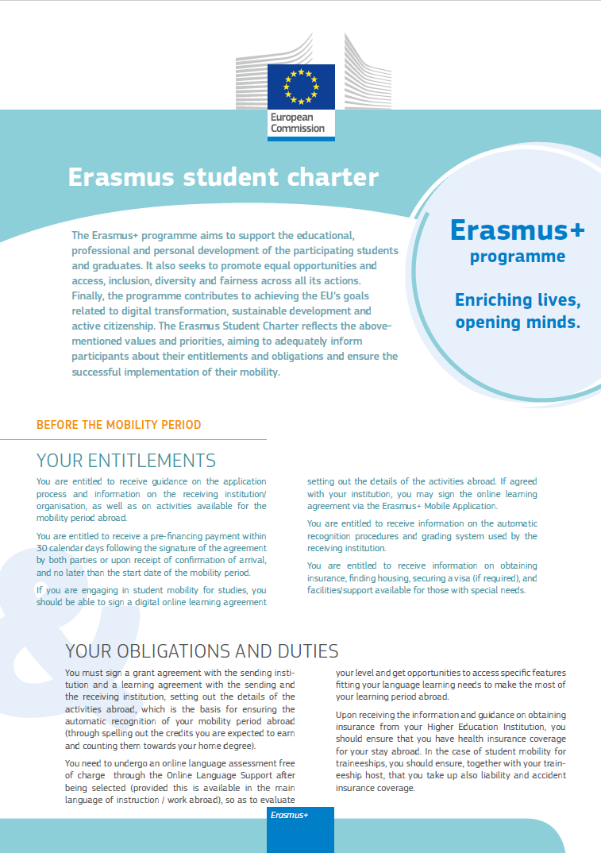

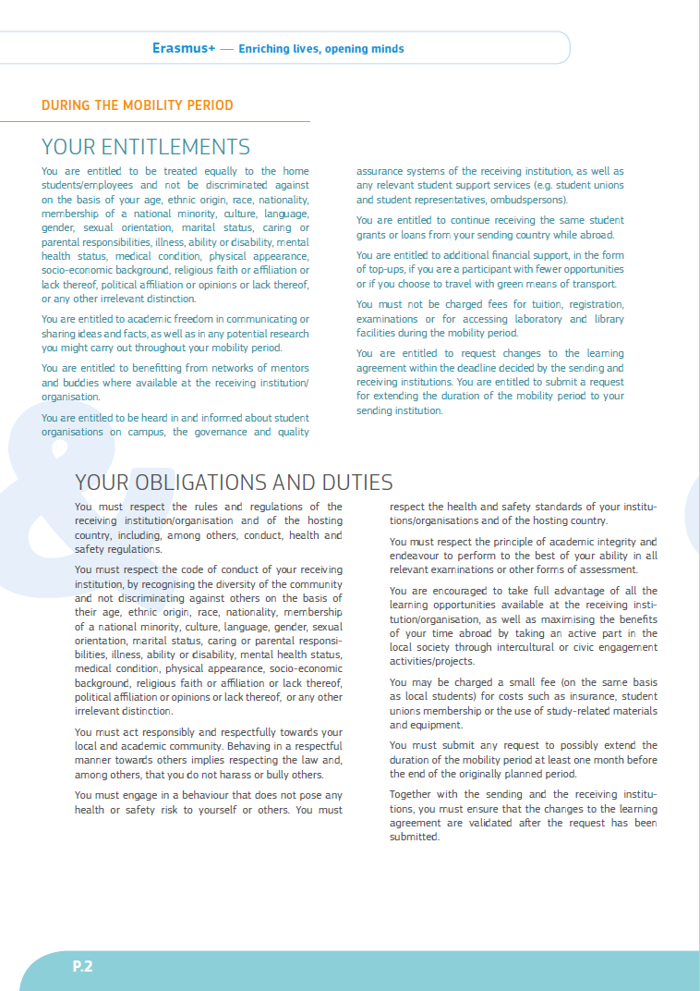

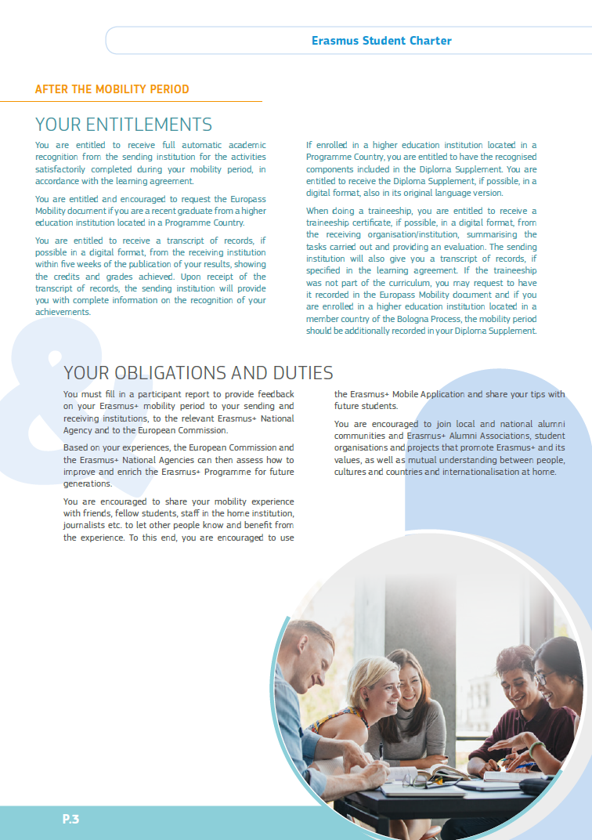

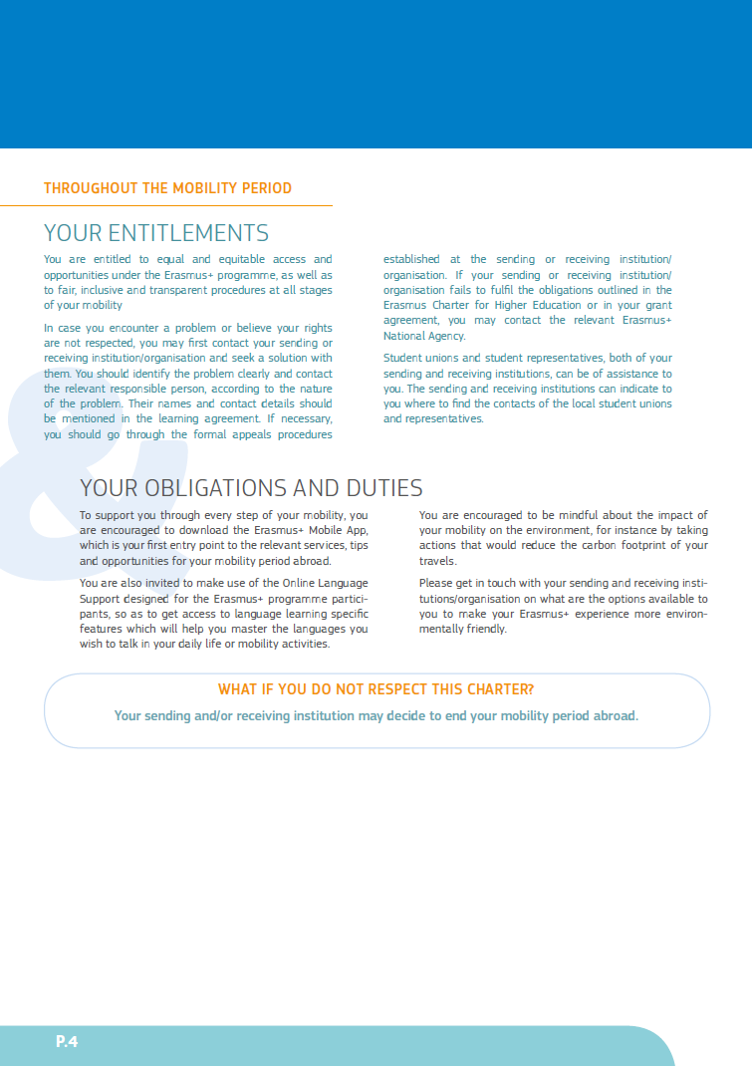

Annex III
COVID-19 VU and Erasmus+ travel policy

In order to apply for the Erasmus-grant, you need to confirm that you are aware of:

- Your study or internship abroad is in line with the VU CvB-policy travelling abroad. You are only allowed to depart to the country of your destiny, in case the travel advice of the destination is green or yellow, or you received a specific exception from the International Office.

- On the day of departure, please make a print screen of the travel advice (https://www.nederlandwereldwijd.nl/reisadvies). Please send the print screen to erasmus@vu.nl. Also make sure to save a copy for yourself.

- In case the travel advice is green or yellow, you can continue with your Erasmus grant application. In case you departed to your host country with travel advice code green or yellow and you have to return early you are only allowed to keep your Erasmus grant, as agreed upon in your Grant Agreement if you continue your activities online. If you are not able to continue your activities online, you will only receive your Erasmus grant for the actual period of your stay abroad.
- In case the travel advice is orange on the day of departure, you are not entitled to the Erasmus grant, unless you have received specific exception for your study abroad. In case you do depart with an orange travel advice and an approval for your departure, please be aware that the following rules apply:
- In case you depart with an orange travel advice to your destination, and you need to return early because of a COVID19-situation within 90 days of your departure, you are no longer entitled to your Erasmus grant. In case you have already received a first payment, you need to return the first payment to VU. It is possible to make arrangements to do so.
- In case you depart with an orange travel advice to your destination, and you need to return early because of a corona-situation after 90 days of your departure, you are entitled to your Erasmus grant, but only for the period you were abroad and studying at the host university. In case you have already received a first payment and that amount is higher than the actual awarded grant, you need to return part of the first payment to VU. It is possible to make arrangements to do so.
- Please keep in mind that, any costs in the event of cancellation or early return (repatriation) due to a new outbreak will not be reimbursed from VU central means.

By signing this Grant Agreement, you confirm that you are aware of this COVID-19 VU and Erasmus+ travel policy.

Nationality: country to which the person belongs administratively and that issues the ID card and/or passport.
Study cycle: Short cycle (EQF level 5) / Bachelor or equivalent first cycle (EQF level 6) / Master or equivalent second cycle (EQF level 7) / Doctorate or equivalent third cycle (EQF level 8).
Field of education: The ISCED-F 2013 search tool available at http://ec.europa.eu/education/tools/isced-f_en.htm should be used to find the ISCED 2013 detailed field of education and training that is closest to the subject of the degree to be awarded to the student by the Sending Institution.
Erasmus code: a unique identifier that every higher education institution that has been awarded with the Erasmus Charter for Higher Education (ECHE) receives. It is only applicable to higher education institutions located in Programme Countries.
The ISCED-F 2013 search tool available at http://ec.europa.eu/education/tools/isced-f_en.htm should be used to find the ISCED 2013 detailed field of education and training that is closest to the subject of the degree to be awarded to the trainee by the sending institution.
The size of the enterprise could be, for instance, 1-50 / 51-500 / more than 500 employees.
For the Common European Framework of Reference for Languages (CEFR) see http://europass.cedefop.europa.eu/en/resources/european-language-levels-cefr

