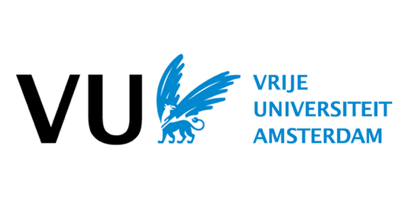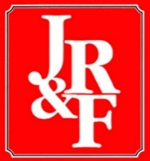

2022 INTERNATIONAL CONFERENCE ON RELIGION & FILM
June 8-10, 2022
Vrije Universiteit Amsterdam, The Netherlands

Call for Papers

The 2022 International Conference on Religion & Film is themed ‘Visions of a Better World’ and aims to encourage scholars from around the world to consider the relation between religion and film from this perspective. It will feature several keynotes and panels on the topic of film and the politics of lived religion.

Religion and film share a great similarity. Both are involved in world-building and meaning-making practices. Both offer sources for inspiration. Both create symbolic and mythical worlds and it-could-be-otherwise realities, utopian as well as dystopian. As such, film can function as religion, a perspective that has inspired many scholars to analyze film from a hermeneutical perspective, looking for the religious dimensions of film. Mostly, such a perspective entails an analysis of the symbolic layers of film, the narrative and mythical elements, and the theological themes.
Focusing on lived experience, we are interested in what film brings about on the level of the individual, but also on the societal and cultural level. What kind of experiences does film produce? And what is the impact of these experiences? Does watching a movie have, instead of being a temporary escape from reality, an impact other than entertainment? Does film have the power to change people? Can movies shape our hopes, fears, desires, and our involvement in the world? Can they create a hyperreality (Baudrillard) that forms the basis of how we understand social and political reality? And ultimately: does film have the potential to contribute to a better, or at least a different world, or the ability to change how we see and approach the world around us?

We welcome papers that connect to this lived religion perspective on film. As customary, we also invite papers and panel discussions from all perspectives on religion and film: from the analysis of individual films, to historical perspectives on religion and film, methodologies for religion and film pedagogy, religious themes in film, or film genres in relation to religion. We encourage discussion of films from around the world.

Keynote speakers for the 2022 Conference are John Lyden, Professor of Religious Studies at University of Nebraska Omaha (USA) and Sheila Nayar, Adjunct Professor at Film and Media Arts at University of Utah (USA).

Proposal Submission: A 350-word abstract of your proposal should be sent to visionsofabetterworld.frt@vu.nl. In a separate document you should provide your name and academic affiliation. The deadline for submissions is March 1st, 2022.

The 2022 International Conference on Religion & Film is co-sponsored by Vrije Universiteit Amsterdam and the Journal of Religion and Film, published by the University of Nebraska at Omaha.

For further information please contact the conference committee at visionsofabetterworld.frt@vu.nl.

