VU Amsterdam International Office

Staff Accommodation Guide

Short Stay Accommodation

The international office has a limited number of short stay housing for incoming PhDs, Guests, Interns, and Staff. We have options available via the housing corporation DUWO and options via Hotel Jansen.

The DUWO Short Stay accommodation concerns fully furnished studios with private facilities. Shared washing/drying facilities are present and a TV and a non-wireless internet connection is included in the rental price. Depending on the type of housing the price of Short Stay accommodation varies between €,- and €1000,-. The minimum rental period is one month, the maximum period 12 months. Rental contracts can never be extended beyond 12 months nor can we offer a new contract for another apartment.

Rental Prices
Rent prices in the document are subject to change, new rental prices will be determined in May 2023. The rent increase follows the inflation standard and will be around 5% plus possible VAT increase. Please note, due to the energy crisis in Europe the expectation is that there will be an increase in the service costs! The current service costs are included in the average price.

Housing Allowance
It can be possible to apply for the Housing allowance (huurtoeslag). This is a subsidy provided by the Dutch government to tenants with a low income and a relatively high cost of rent. Some of the rooms we provide qualify for housing allowance. Find out more about which housing types are eligible on the following pages. For more general information about housing allowance and on the eligibility for this subsidy, please visit this link.

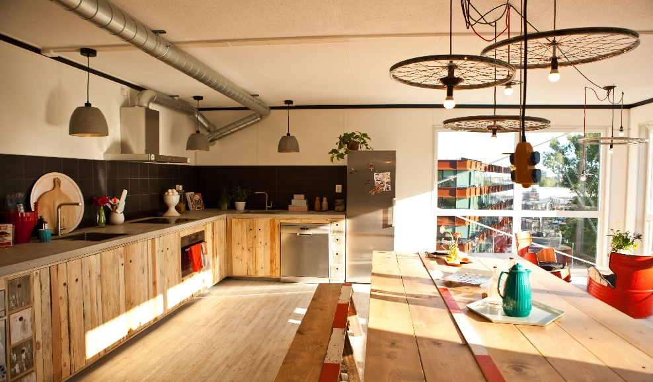
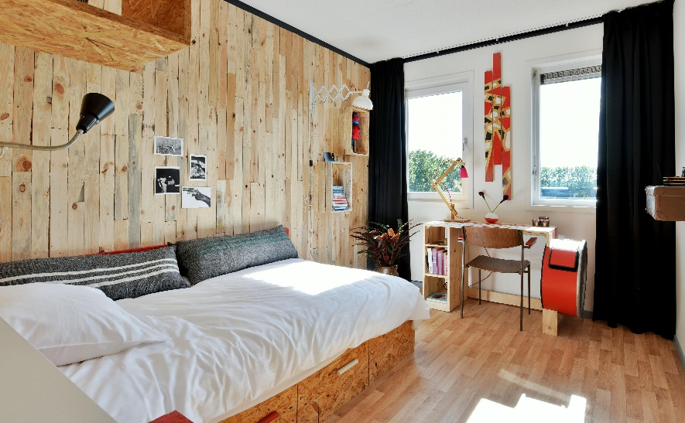

Hotel Jansen

Hotel Jansen is an all-inclusive Short Stay hotel in Amsterdam, located at a 10 minute cycle ride from VU Amsterdam. Hotel Jansen accommodates students, graduates, interns and young professionals from all over the world. They strive to create an authentic home away from home with 166 uniquely designed rooms, 5 clubrooms and a restaurant. All rooms and floors are unique, with handcrafted furniture and art that are designed by a collective of Dutch artists and carpenters.
We have arranged a special deal: a room at Hotel Jansen for a minimum of 1 month and maximum stay of 6 months. Monthly rent €875 including all service charges; gas, electricity, water, cleaning costs for the public areas and club rooms, garbage removal and city taxes. Extra costs are one time €250 per booking, regardless of the length of stay (Administration, final cleaning, and linen package). Please note that this type of accommodation is highly demanded.

You may find more information about Hotel Jansen on their website: www.hoteljansen.nl

Type of room | Ensuite bedroom with private bathroom for 1 person
Kitchen | Shared with 26, cleaned daily by a professional
Size | 18m2
Rental price per month | € 875 (including service charges)
Deposit | € 700
Admin fee | € 250
Parking | Paid
Laundry | Shared (pay per use)
Number of units | 10
Internet | 300 Mb/s Wi-Fi throughout the entire Hotel
Period | Max. 6 months  Starting date per the 1st of the month and move-out dates are fixed for every 15th or last day of the month

View on Google Maps
Uilenstede Oost 510

Uilenstede Campus is a student district at the outskirts of Amsterdam, in the municipality of Amstelveen. The campus provides many amenities, such as a large cafe, supermarket, snack bar, bicycle repair shop, sports centre, theatre, pizzeria, beauty salon & diving school.

The builing Uilenstede Oost 510 is located in Amstelveen, approximately 10 minutes by bike, 14 minutes by public transit, and 25 minutes by walking from the university.

This room is fully upholstered and furnished. More information about the basic furnishing of the room can be found here. You have your own kitchen and private sanitary facilities. The kitchen has a refrigerator and a hot plate. There is a box with kitchen utensils waiting for you or the kitchen is equipped upon arrival. You only need to bring your personal items.
There is also a laundry room in or near the complex where you can do your laundry (pay per use). There is Wi-Fi in your room. Just check the log in information on the router, enter this on your device and you are online!
The first payment consists of:
- First month’s rent
- € 16 admin fee
- € 95 cleaning costs
- € 55 bed linen package
- € 65 kitchen and welcome package
More information about the locations, and descriptions of the different types of studios are described below.
View on Google Maps

Location of Building Uilenstede 510
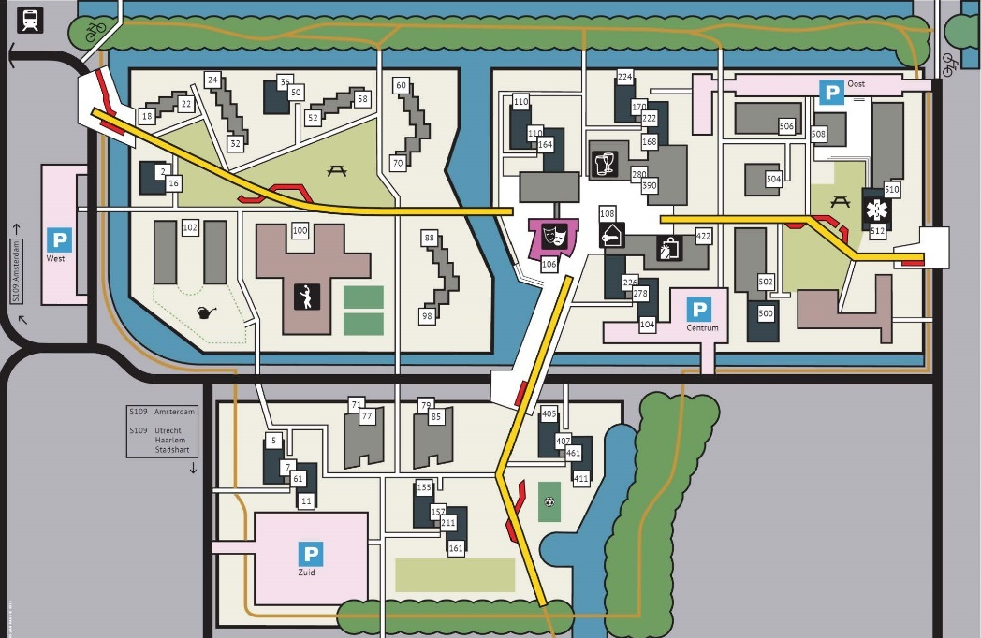

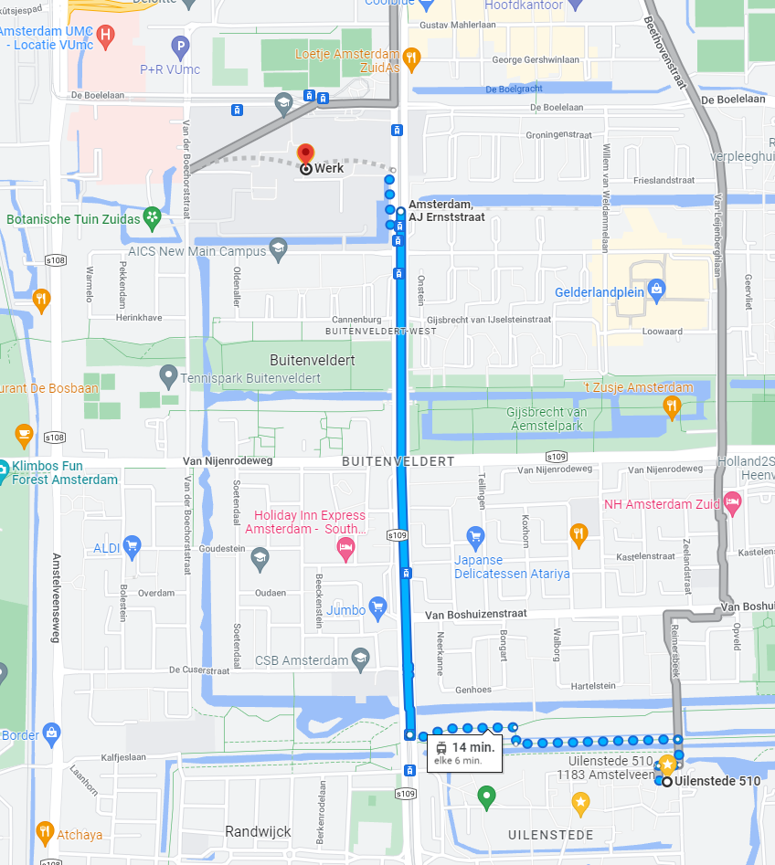
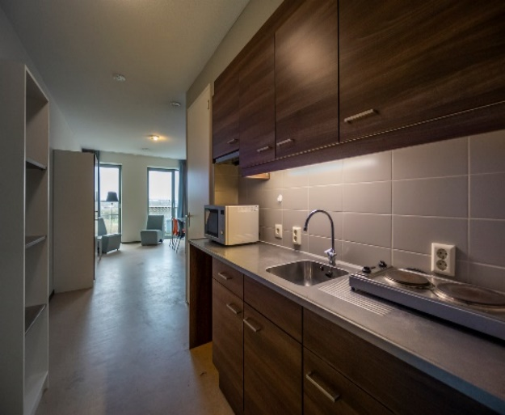
Uilenstede Oost 510 – Type A

Type of room | Private studio for 1 person
Size | 29 m²
Cable internet, water & electricity | Included in the rental price
Rental price | € 638,31
One-time costs | € 231 (cleaning costs, linen and kitchen package)
Parking | Paid
Number of units | 13
Housing allowance | Eligible from age 18 or older
More information | Here

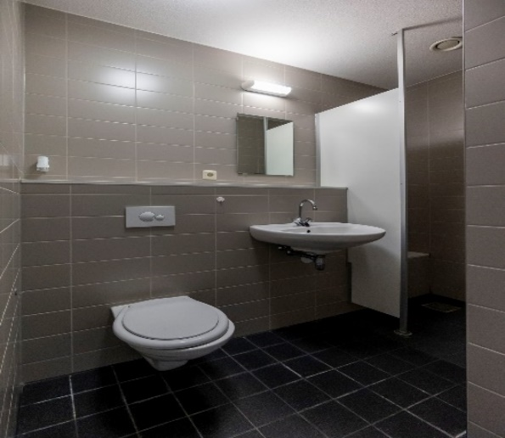

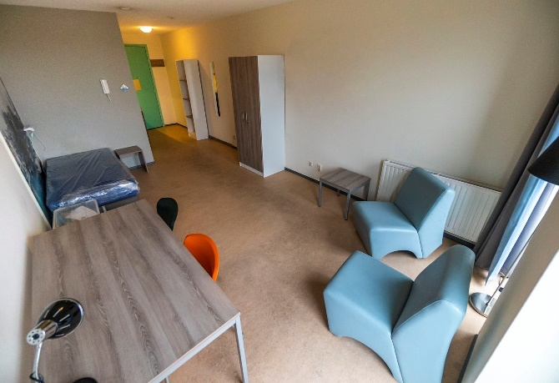

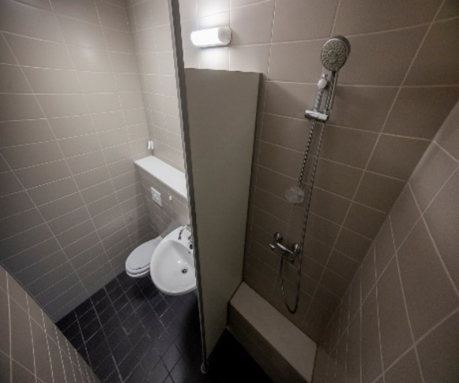

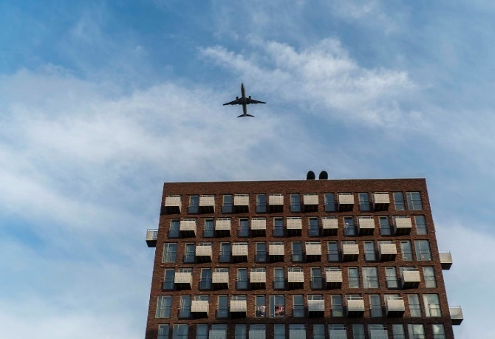
Uilenstede Oost 510 – Type B

Type of room | Private studio for 1 person
Size | 29 m² + small balcony
Cable internet, water & electricity | Included in the rental price
Rental price | €826,60
One-time costs | € 231 (cleaning costs, linen and kitchen package)
Parking | Paid
Number of units | 77
Housing allowance | Eligible from age 23 or older
More information | Here

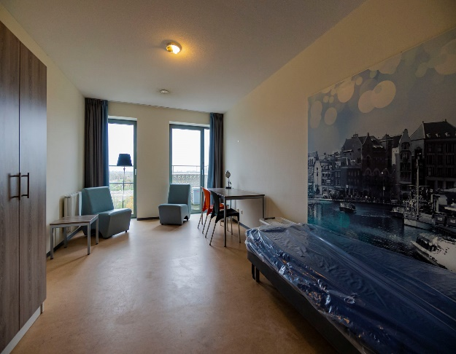

- Click here for virtual tour!

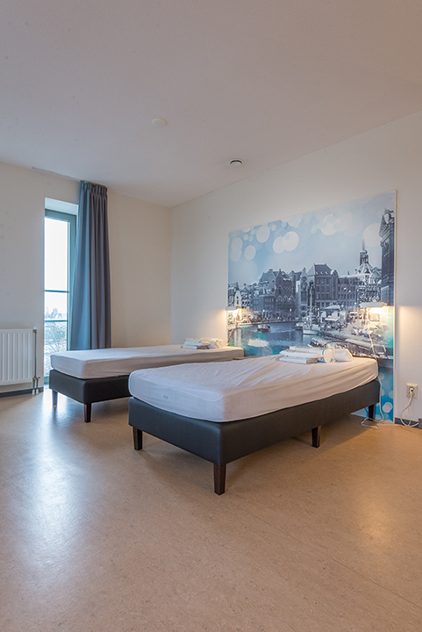
Ui Uilenstede Oost 510 – Type C

Type of room | Private studio for 1 or 2 persons (couple)
Size | 46 m² + balcony
Cable internet, water & electricity | Included in the rental price
Rental price | € 863,06
One-time costs | € 231 (cleaning costs, linen and kitchen package)
Parking | Paid
Number of units | 9
Housing allowance | Eligible from age 23 or older
More information | Here

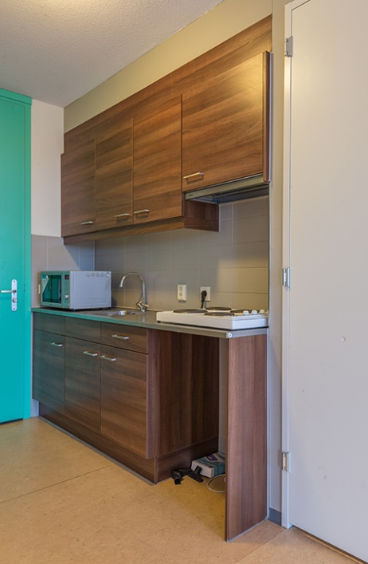

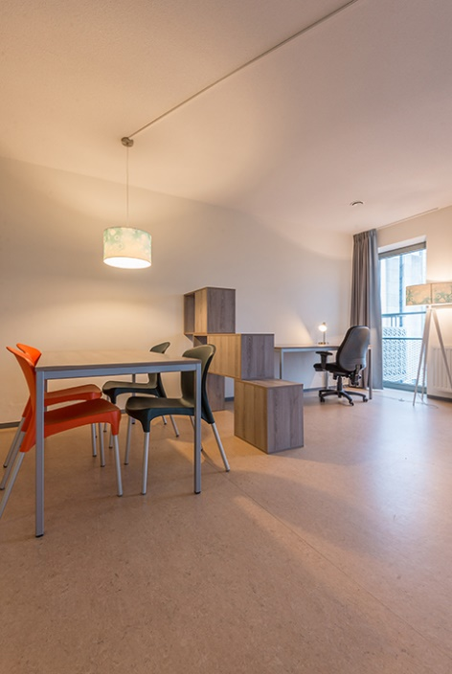

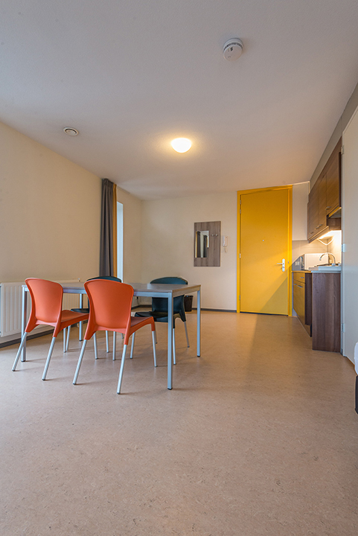
Uilenstede Oost 510 – Type D

Type of room | Private studio for 1 or 2 persons (couple)
Size | 50 m² + balcony
Cable internet, water & electricity | Included in the rental price
Rental price | € 873,06
One-time costs | € 231 (cleaning costs, linen and kitchen package)
Parking | Paid
Number of units | 9
Housing allowance | Eligible from age 23 or older
More information | Here

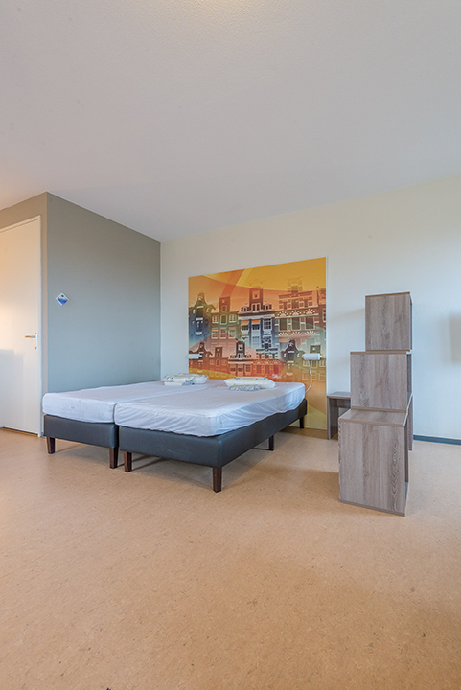

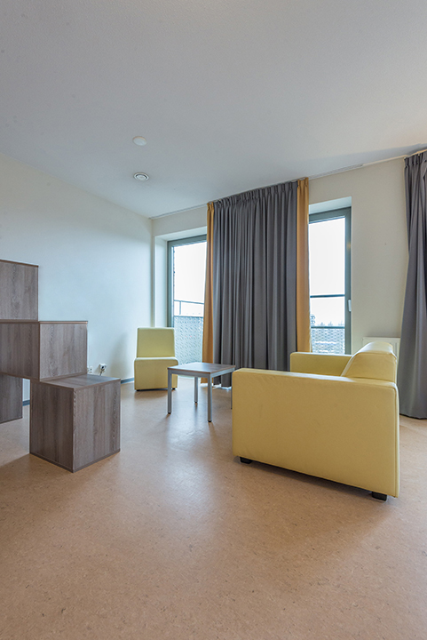
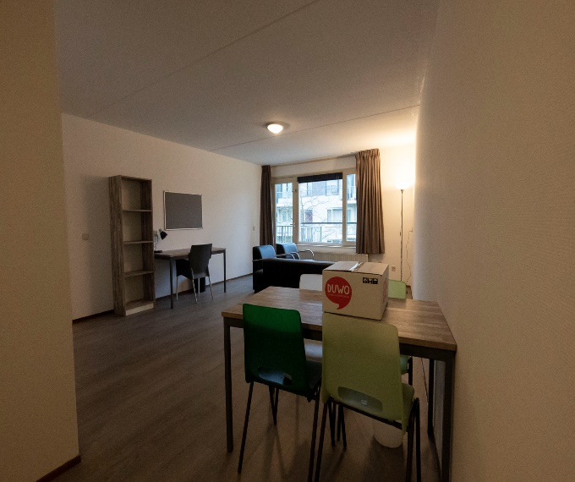
Uilenstede – Atrium Couple

Type of room | Room for couple – 1 bedroom
Size | 53 m²
Cable internet, water & electricity | Included in the rental price
Rental price | € 948,18/ € 1.060,64
One-time costs | € 231 (cleaning costs, linen and kitchen package)
Parking | Paid
Number of units | 2
Housing allowance | Eligible from age 23 or older
More information | Here

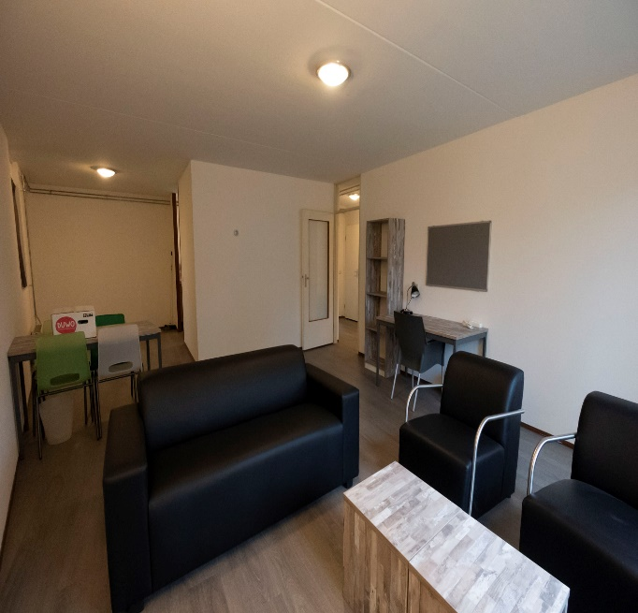

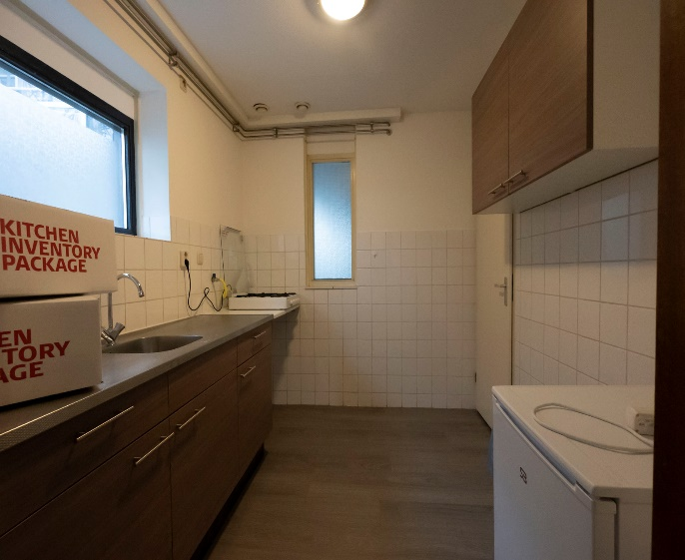
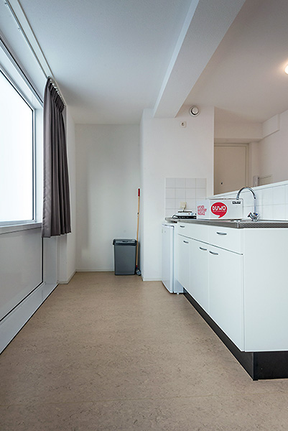
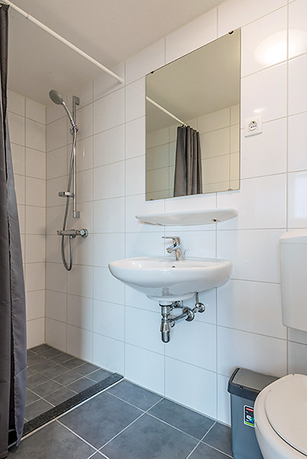
DUWO – Pierre Lallementstraat
Type of room | Private room for couple
Size | 29 m²
Cable internet, water & electricity | Included in the rental price
Rental price | € 807,17
One-time costs | € 230 (cleaning costs, linen and kitchen package)
Parking | Paid
Number of units | 4
Housing allowance | Eligible from age 23 or older
More information | Here

