How to apply for Dialogue, Health and Society, a specialization of the MA programme Communication and Information Studies at the Vrije Universiteit Amsterdam.

Go to studielink.nl where you can fill out some pre-specified boxes to search the study programme database, such as educational institution, study programme level, academic load and main language.
Use the search string COMMUNICATION, and make sure you select VRIJE UNIVERSITEIT under ‘EDUCATIONAL INSTITUTION’ and select MASTER under ‘STUDY PROGRAMME LEVEL’.
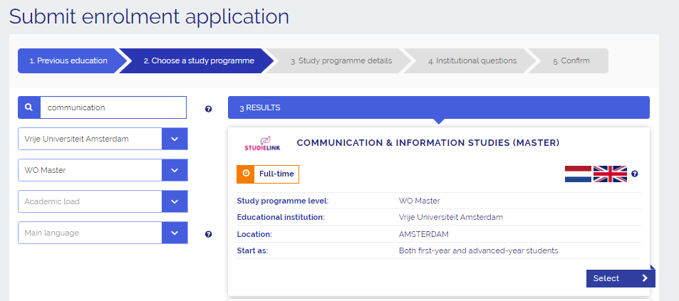

When selecting this programme, you will be taken to step 3 in your enrollment. Please note that you don’t have to specify Dialogue, Health & Society at this time in studielink, as can be shown in the figure below
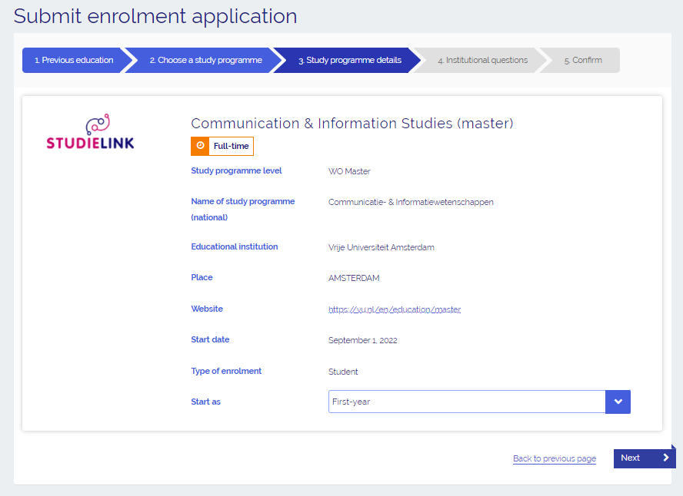
You can complete your enrolment and specify Dialogue, Health and Society later on in the process, when you are in contact with the Admissions Office.

REFRAIN FROM USING OTHER SEARCH terms (such as COMMUNICATION AND INFORMATION, as displayed below) as they don’t give any hits in Studielink.nl
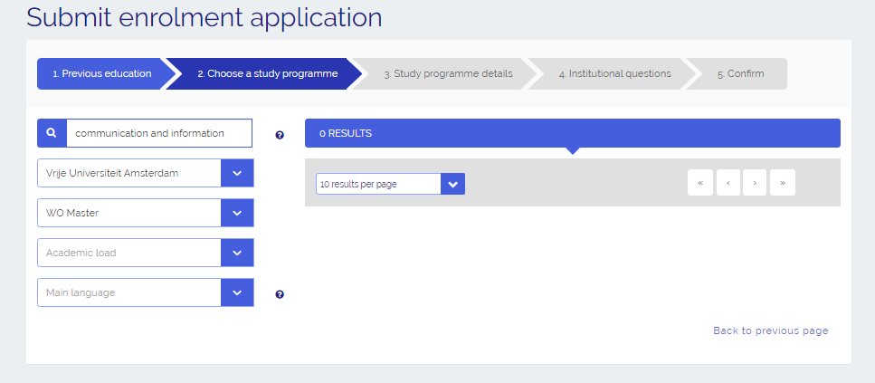

Also leaving the prespecified fields ‘EDUCATIONAL INSTITUTION’ and ‘PROGRAMME LEVEL’ BLANK will make it very hard to find the MA CIS study programme offered at the VRIJE UNIVERSITEIT.

