Each thesis should contain the following statement after the title page and before the table of contents and should be signed by hand.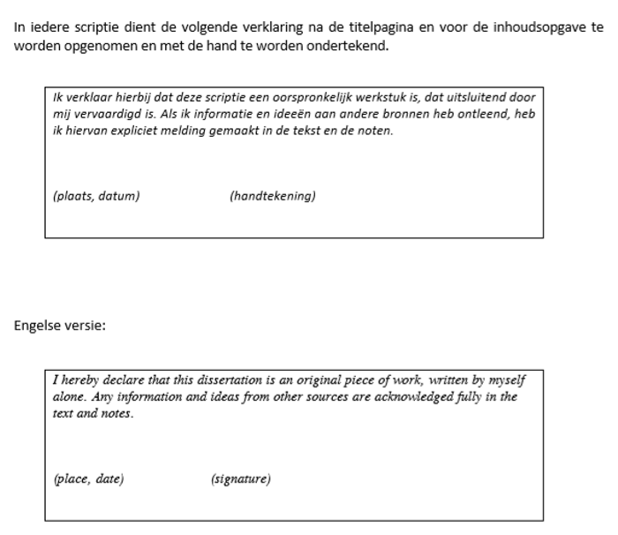

In iedere scriptie dient de volgende verklaring na de titelpagina en voor de inhoudsopgave te worden opgenomen en met de hand te worden ondertekend.
Each thesis should contain the following statement after the title page and before the table of contents and should be signed by hand.

Ik verklaar hierbij dat deze scriptie een oorspronkelijk werkstuk is, dat uitsluitend door mij vervaardigd is. Als ik informatie en ideeën aan andere bronnen heb ontleend, heb ik hiervan expliciet melding gemaakt in de tekst en de noten.

(plaats, datum) (handtekening)

Engelse versie / English version:
I hereby declare that this dissertation is an original piece of work, written by myself alone. Any information and ideas from other sources are acknowledged fully in the text and notes.

(place, date) (signature)

