Coauthored UPASS Program Textbook “Markets and Governments: Transport Economic Theory and Applications” Officially Published
The textbook titled “Markets and Governments: Transport Economic Theory and Applications” ,coauthored by UPASS program members Prof. Erik Verhoef from Vrije University Amsterdam, Prof. Yacan Wang and Dr. Yamei Hu from Beijing Jiaotong University, was recently published by Social Sciences Academic Press in China. Several faculty members from the School of Economics and Management of Beijing Jiaotong University also contributed to writing this book, including Prof. Zhigang Cao, Associate Professor Peihong Chen, Associate Professor Jingjuan Jiao, Prof. Hongchang Li and Associate Professor Huiyu Zhou. Prof. Chaohe Rong, well-known Chinese researcher in the field of transport economics, wrote the preface for the book upon invitation. This book is one of the milestone achievements of the China-EU cooperation program “Urban public administration and service innovation: new-type urban mobility management and policy” (program Nr: 71961137005) funded by the National Natural Science Foundation of China (NSFC) and Joint Programming Initiative Urban Europe (JPI UE).
This problem-oriented textbook not only systematically explains how to analyze core issues of transport economics using standard tools of microeconomics and welfare economics and but also demonstrates how to deduce policy conclusions from these analyses. Different from existing textbooks, this book directly focuses on systematic analysis of urban traffic congestion from the perspective of market failure, instead of providing a general introduction to the transport sector and its economic principles. This book consists of 7 chapters: chapter 1 addresses the issue of traffic congestion by treating it as a market failure. Chapter 2 discusses the theory and application cases of road congestion pricing. Chapter 3 further analyzes the different ways to charge fees for road congestion and the resulting market results. Chapter 4 elaborates on market forces in the transport sector and discusses how to regulate them. Chapter 5 discusses travel time value theory and introduces estimation methods through empirical studies. Chapter 6 explores the cost-benefit analysis method, an important technique used by government to evaluate the feasibility of potential investment projects. Chapter 7 discusses the development of behavioral economics and its application in the fields of transport and travel, with a focus of applying the theories of behavioral economics in the formation of transport policy.

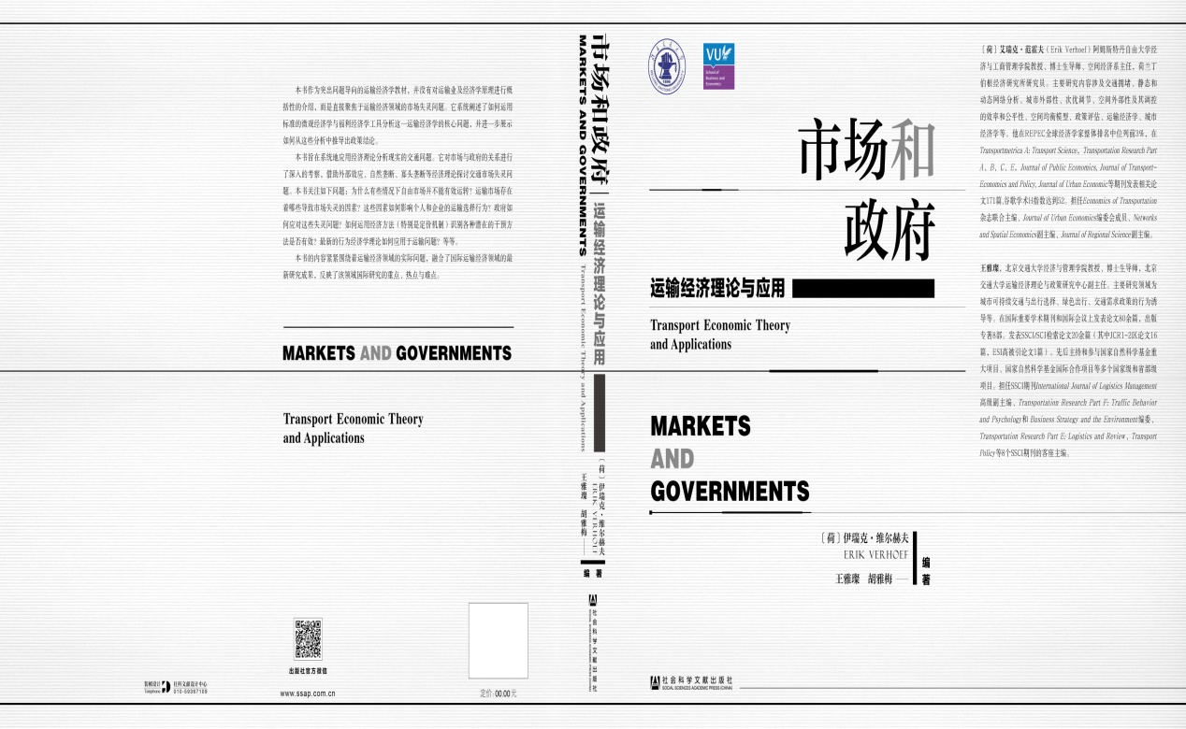
The textbook will help a lot in advancing teaching and research efforts in transport economics since it traces the international research priorities by addressing real problems in the sector of transport and incorporates both the frontier international research findings in the field of transport economics and the case studies on China’s transport sector. It thus effectively fills in the gap of lacking textbooks specialized on studying transport problems by use of frontier economic theories and methodology in China. Currently, the book has been adopted by the School of Economics and Management, Beijing Jiaotong University, as the textbook for one undergraduate course on transport economics. It has been well received by teachers and students, who deem it as comprehensive, logically rigorous, highly readable, and using exquisite models.
This textbook is a wonderful product of international cooperation between Beijing Jiaotong University and Vrije University Amsterdam under the UPASS program. The first author Prof. Erik Verhoef is the chief professor, deputy dean of scientific research and director of department of spatial economics of the School of Economics and Business Administration of Vrije University Amsterdam, and distinguished researcher with Tinbergen Institute. He ranks among the top 3% in the REPEC overall global economist rankings and among the top 5% worldwide in terms of academic achievements and citations. His research focuses on the efficiency and fairness of spatial externalities and their economic regulation, and the textbook “the Economics of Urban Transportation” coauthored by him and Prof. Kenneth Small is recognized as the most-cited textbook of transport economics in the world. Prof. Erik Verhoef has published 171 papers in Transportmetrica A and Transportation Research Part A, B, C and E and other journals, with Google Scholar H index of 52. Currently, he serves as the joint editor in chief of Economics of Transportation, member of editorial committee of Journal of Urban Economics, associate editor in chief of Networks and Spatial Economics and associate editor in chief of Journal of Regional Science.

