Table of Contents
Federal loans for US students
1 Introduction
1.1. Direct Loan types:
2 Applying for financial aid
3 Financial information; Cost of attendance
4 Federal Student Loans Direct Loan
4.1 Direct Subsidized and Unsubsidized loan amounts
4.2 PLUS loan or Parents Plus loan
4.3 Plus loan amounts
4.4 Aggregate Loan limits
4.5 Fees US Government
5 Procedures at Vrije Universiteit Amsterdam:
5.1. Eligibility for financial aid
5.2 Award letter
5.4 Deadlines Vrije Universiteit
5.5 When and how you will receive your loan?
6 Satisfactory Academic Progress
8 In-School Deferment Request
9 Repayment Period
10 Refund policy
11 Alcohol and Drugs

Federal loans for US students

1 Introduction
Vrije Universiteit Amsterdam is an approved Title IV institution, which allows US students to access Direct loans and PLUS loans through the US Direct Loan Program. In this program, the U.S. Department of Education lends the money directly to students through the student’s school. The following types of loans are available: Subsidized loans, Unsubsidized loans and Plus loans. Vrije Universiteit Amsterdam’s students are not eligible for Pell grants, Perkins loans, or other types of US Federal financial aid.

1.1. Direct Loan types:
- Direct subsidized loans: for eligible undergraduate students who demonstrate financial need to help cover the costs of higher education at a college or career school.

- Direct Unsubsidized loans: for eligible undergraduate, graduate and professional students. (no need to demonstrate financial need to be eligible for the loan)

- Plus Loans /Parent loans: are loans made to graduate or professional students and parents of dependent undergraduate students to help pay for education expenses not covered by other financial aid.

2 Applying for financial aid

Step 1: Apply for study programme at Vrije Universiteit Amsterdam
If you want to apply for a loan to study at Vrije Universiteit Amsterdam, you must be (conditionally) accepted for the study programme. On our website, you can find all information about the study programs. It is not possible to use a loan for the following programs:
- Medicine
- Dentistry
- Exchange programs / Study abroad programs (For these programs, you can receive financial aid from your home school in the US.)

Step 2: Free Application for Federal Student Aid (FAFSA)
The first step in applying for a US Federal Loan is to complete the FAFSA online form: Free Application for Federal Student AID. You can do this at: www.fafsa.ed.gov.
The school code of Vrije Universiteit Amsterdam is: G08376.
An instruction video for the financial aid process can be found here!
To complete the FAFSA online, you must have an FSA ID. For more information, please check here.
Completing the FAFSA is not a student loan application. It generates a Student Aid Report (SAR) that Vrije Universiteit uses to determine your eligibility for financial aid.

Step 3: Loan application and required documents
To apply for Federal Loans, go to: https://studentloans.gov/myDirectLoan/index.action to complete the Loan Application. Depending on your situation, you will need to complete also other documents:
Master Promissory Note (MPN):
The MPN is the legal document through which you promise to repay your Direct Loans and any accrued interest and fees to the Department. It also explains the terms and conditions of your loans.
- If you apply for subsidized/Unsubsidized and Plus Loan, you must complete 2 separate MPN’s.
- You will need to complete a new Direct Loan MPN each academic year that you receive a Direct Subsidized Loan and/or a Direct Unsubsidized Loan as well as for the Plus loan at our school
Entrance Counseling
You may complete Direct Loan Entrance Counseling online via the StudentLoans.gov Web site at https://studentloans.gov/myDirectLoan/counselingInstructions.action.
To complete Direct Loan Entrance Counseling online, you must use the FSA ID. This is the same ID you used to complete the FAFSA.

- If you are completing entrance counseling to borrow a loan as an undergraduate (bachelor) student, then the entrance counseling will fulfill counseling requirements for Direct Subsidized Loans and Direct Unsubsidized Loans.
- If you are completing entrance counseling to borrow a loan as a graduate (master) or professional (PhD) student, the entrance counseling will fulfill counseling requirements for Direct Subsidized Loans, Direct Unsubsidized Loans, and Direct PLUS Loans.

Credit check:
Credit check is only applicable for Plus loan applications: The credit check is to determine whether you have an adverse credit history.
Step 4: Questionnaire Vrije Universiteit
You must complete the questionnaire of Vrije Universiteit and e-mail this to: usloanprogram.dsz@vu.nl
You can find the questionnaire here.

3 Financial information; Cost of attendance
The cost of attendance (COA) is the total tuition fees and living expenses determined by the University. The figures below include the average tuition fee, living costs and accommodation. The sum of your loans and other aid, such as scholarships and grants, cannot exceed the total COA. For the exact tuitions fees for bachelor and metaprogrammes, please check here.
You may choose how much you need to take out, you don’t have to take the full amount.
If you have a scholarship or are awaiting a decision, you should inform Vrije Universiteit.
Example Cost of Attendance:
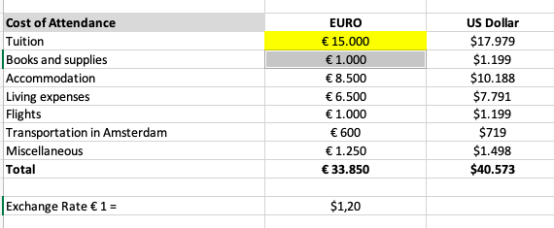

4 Federal Student Loans Direct Loan
The Direct Loan is made up of two parts; Subsidized and Unsubsidized and is available to all students. Subsidized loans are only available for undergraduate (bachelor) programmes.
The Subsidized and Unsubsidized Loans do not enter repayment until six months after you have completed the course or dropped below 50% attendance.
Please check out the current interest rates here. These figures may change, so you are encouraged to check interest rates when applying for your loans.

- Subsidized: assessed on financial need, as determined by Federal regulations. No interest is accrued while you are in school at least halftime, during the grace period and during deferment periods. Please note during the grace period, interest accrues for Subsidized Direct Loans.
- Unsubsidized: not based on financial need. Interest is accrued during the period of study and during the grace and deferment periods.
- For an overview of loans disbursed before 1 July 2017, see https://studentaid.ed.gov/sa/types/loans/interest-rates#interest-rate-factor

4.1 Direct Subsidized and Unsubsidized loan amounts
The table below shows the amounts of Direct loan a student can borrow depending on the course and year of study. It depends also whether you have the status of Independent or Dependent. For more information, check here.
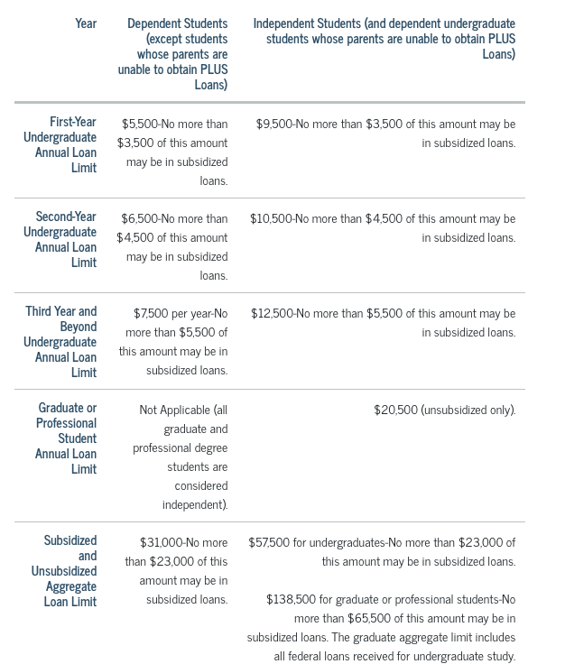

As you can see from these amounts, the Direct Subsidized and Unsubsidized Loan is not enough to pay the full cost of your tuition for undergraduate courses and some postgraduate courses. Therefore, you will need to consider how you intend to pay the outstanding balance of your tuition fees and your living expenses. You can make up the difference with your own funds, a Direct PLUS Loan or a private student loan. (For information on Salliemae private loans, click here)

4.2 PLUS loan or Parents Plus loan
The PLUS Loan is available to the parents of dependent undergraduate students and graduate/professional students. The PLUS loan is not available to independent undergraduate students. The PLUS Loan is to help pay the cost of education up to the cost of attendance minus all other financial aid. Interest is accrued during the period of study.
You are advised to check the interest rates when applying for your loans here
- Plus loan for Graduates: Students complete the application. A credit check is required for this loan. You can defer the repayment until six months after the completion date of the course or the date attendance you dropped below 50%. A credit check is required for this loan.

- Plus loan for Parents: the parents take out the loan on behalf of the student to cover education costs. In this case, the parent completes a Direct Loan Application. Parents can defer the repayment until six months after the completion date of the course or the date attendance dropped below 50%. A credit check is required for this loan.

- For an overview of loans disbursed before 1 July 2017, see https://studentaid.ed.gov/sa/types/loans/interest-rates#interest-rate-factor

4.3 Plus loan amounts
The maximum PLUS loan amount you can borrow is the Cost of Attendance of Vrije Universiteit Amsterdam minus other financial assistance, e.g., subsidized, or unsubsidized loans

4.4 Aggregate Loan limits
Students cannot borrow more than the lifetime aggregate loan limit. The student is responsible for not exceeding these limits. The students’ aggregate amounts are detailed in the Student Aid Report. The lifetime aggregate limits for Direct Loans are listed below:
- Dependent student Undergraduate: Subsidized $23,000; Subsidized and Unsubsidized: $31,000.
- Independent student Undergraduate: Subsidized $23,000; Subsidized and Unsubsidized: $57,500.
- Graduate student: Subsidized $65,500; Subsidized and Unsubsidized: $138,500.
- PLUS: no lifetime aggregate.

4.5 Fees US Government
The US government will deduct fees from the loan amounts. This fee is subject to change, you can find all information here.

5 Procedures at Vrije Universiteit Amsterdam:

5.1. Eligibility for financial aid
After receiving your questionnaire and after reviewing your Student Aid Report (SAR) report we will send you a Cost of attendance and eligibility sheet. We also will calculate the amounts you can take out.
The eligibility depends on your:

- Expected Family Contribution (EFC):
  - For need-based aid the eligibility depends on your Expected Family Contribution. The EFC is subtracted from the COA to determine the financial need. Subsidized loans are considered need-based loans. Expected Family Contribution (EFC)
More information about EFC can be found here.
- Other financial aid (e.g., Scholarships)
  - For non-need-based aid, the amounts are based on the COA minus the financial aid that has already been awarded. Unsubsidized loans and Plus loans are considered non-need based. If a scholarship is awarded to you, you must inform us about this. The awarded amount can influence your loan.
- The year in school (undergraduate students): see paragraph 4.1.
- Enrollment status: students must be enrolled at least half-time.
- The cost of attendance: here you can see how much what one year of study at Vrije Universiteit will costs. It includes tuition and fees, living costs and other allowances, see paragraph 3.

Please note: If a scholarship is awarded to you, you must inform us about this. The awarded amount can influence your loan.

5.2 Award letter
If you agree on the conditions of the COA, we will send you an Award Letter with details of the loan(s). You will need to sign it and return it to us before we can originate the loans.
Please be aware that we are unable to process the loan if there are missing documents. If you do not complete the application process and submit all requested documents, we may be unable to complete your financial aid package for the academic year.

5.4 Deadlines Vrije Universiteit
How long does it take to apply for a US Direct Loan?
A regular application takes about four weeks to complete. To guarantee that you will receive the loan funds on time for your visa or tuition fee (see below), please consider the following deadlines:
Deadlines for finalized applications 1st semester:
- 1 August - Access to Financial Aid in September
- 1 September - Access to Financial Aid in October
- 1 November - Access to Financial Aid in December
Deadlines for finalized applications 2nd semester:
- 1 January - Access to Financial Aid in February
- 1 February - Access to Financial Aid in March
- 1 April - Access to Financial Aid in May
Using your loan to pay for tuition fee
If you take out a Federal Direct Loan, you should not pay tuition fee yourself, as the VU will deduct your tuition fee from your loan amount. To do so, you need to complete both your loan application and your enrollment with VU before 20 August.

5.5 When and how you will receive your loan?
You will receive your loans once you have arrived at the university and completed registration. The loan is paid into your Dutch bank account, which you will open after arrival.
The balance after tuition fees have been deducted will be paid into your Dutch bank account. US Government regulations state that your loan must be disbursed over two semesters. Payment of your loan will be made at the start of each term. Please ensure you have sufficient funds to cover about 1 month's living costs at the start of the academic year.
General Disbursement dates:
- First semester: mid-September
- Second semester: Mid-February
This is just a general indication; dates are determined annually.

6 Satisfactory Academic Progress
All students applying for or receiving US Federal Aid (subsidized, unsubsidized and PLUS /Parent) must progress satisfactory towards completion of the study programme at Vrije Universiteit to remain eligible for federal financial aid. Please check the complete regulation here.
Satisfactory academic progress will be checked before any loan proceeds are paid to a student. If the student does not meet the criteria satisfactory academic progress, the student may lose their entitlement to US loan support. Please read the complete regulation on our website.

8 Programme Eligibility & Study Abroad or Internships
Students with a Federal Direct Loan face restrictions in their options to study abroad, including research, field trips and internships. It is important to contact the Financial Aid Office before planning to undertake this kind of activity.
If you do not contact the Financial Aid Office before undertaking an internship or study activity outside of Vrije Universiteit Amsterdam or the Netherlands, you run the risk to lose your loan eligibility for the entire loan period and possibly beyond, including already received aid.
Regulations will potentially allow:
- Undergraduate and Graduate students receiving US federal loans to take up 25% of their study programme in the United States or at institutions outside the US through a written agreement.
- PhD students doing independent research in the US, the maximum period is 12 months during their dissertation phase of their doctoral program (If this can only be performed at a facility in the US)
If you plan to undertake any periods of study or research away from Vrije Universiteit during your course, please email the US loans team before applying for your loan so that we can assess your eligibility. It is important that you contact us at the beginning of your course so that we can advise accordingly, even if you will not be completing study outside at Vrije Universiteit until a future year of study.

7 Exit Counselling
A Student Direct Loan borrower who is graduating, leaving school, or dropping below half-time enrolment is required to complete exit counselling
You will have to complete Exit Counselling before you complete /quit your course to ensure that you understand the repayment terms of your loan.
You can complete the counselling session online through:
https://studentloans.gov/myDirectLoan/counselingInstructions.action

8 In-School Deferment Request
You may be able to defer repayments on previous Federal loans and Private Education loans while you are enrolled at least half time at Vrije Universiteit Amsterdam. To do so please contact your lender for the In-School Deferment Request form.

9 Repayment Period
The Direct Loan Program offers loan repayment plans designed to meet the needs of borrowers and allows you to choose your repayment plan. These loans can be repaid within 10 to 25 years depending on which repayment plan you choose. Repayments of your Direct Loans normally start six months after completion of your course, withdrawing or dropping below 50% attendance. You can find out more about repayment options before receiving a Direct Loan by going to: https://studentaid.ed.gov/sa/repay-loans or you can contact the Federal Student Aid Center on 001 800 4 FED AID (001 800 433 3243). See also the Default and Management plans on our website.

10 Refund policy
If you are terminating your study programme, you must arrange several things:

1) Inform the Financial Aid Officer of Vrije Universiteit Amsterdam
2) Submit a de-registration request to Studielink ( www.studielink.nl)
3) See whether you will be reimbursed any excess tuition

If you receive Federal financial aid and decide to withdraw from your course, interrupt your studies or study less than half the time please inform the Student Funding Office as soon as possible.
The University is required by Federal Law to recalculate your Financial Aid eligibility based on the period of attendance. As a result, you may be required to pay back money to the US Federal Government from the Federal Direct subsidized and unsubsidized or Direct PLUS loans you have received according to the terms of the Master Promissory Note.

In certain cases, Vrije Universiteit Amsterdam may reimburse a portion of the tuition you have paid. For every full month of the academic year for which you are no longer registered, you receive 1/12 of your tuition back.

- Did you pay in instalments? In this case the direct debits will be discontinued
- Did you de-register as of July 1 or August 1? You are not entitled to reimbursement of the tuition paid for these months; to this end we refer you to VU Adam’s Enrolment Provisions
- Alternatively, you can choose not to de-register for the months of July and August

For example: You withdraw March 5 > De-registration valid from April 1. Reimbursement of tuition for April, May, June, July, August = 5/12 of paid tuition

11 Alcohol and Drugs
The US Department of Education provides information on the penalties associated with drug-related offences under the US Higher Education Act. Students who lose eligibility for US student loan because of these penalties, will receive from Vrije Universiteit a written notice which notifies the loss of eligibility and advise to regain eligibility.

Vrije Universiteit Amsterdam, drugs and alcohol policy
- All rights and responsibilities of students studying at Vrije Universiteit Amsterdam are outlined in the Student Charter.
- Students that are found guilty within the legal jurisdictions of The Netherlands during their period of study will lose their eligibility for Federal Student Aid.
Drugs policy in the Netherlands
In the Netherlands, the Opium Act sets out the rules pertaining to drugs. Read all information about the Dutch drug policy, drug prevention, drug law here.
Alcohol policy in the Netherlands
The Dutch government tries to prevent alcohol abuse and alcoholism through laws and public and awareness. There are several laws governing alcohol. Find more information here.

Counselling and information Services in the Netherlands / Amsterdam
- Alcoholics Anonymous: Offers help to recover from Alcoholism: telephone: +3120625 60 57
- Narcotics Anonymous: Offers help to recover from Drug addiction. Telephone: +31622341050
- National emergency number: 112
- GPA: 088-0030600 (24/7)
- Dutch Association of mental health and addiction care (GGZ): Amsterdam: +31 20 788 5333

