Table S1
Sample Descriptives of Final Samples of Prestudy and Main Study
Demographic characteristic | Prestudy  N = 414 | Main Study  N = 8,016
Gender/Sex ª (n (%))  Female  Male  Other  Prefer not to say | 318 (76.8%)  88 (21.3%)  7 (1.7%)  1 (0.2%) | 5,540 (69.1%)  2,476 (30.9%)  N/A  N/A
Highest obtained Education (n (%)) ^{b}  Low  Moderate  High | 5 (1.2%)  176 (42.5%)  233 (56.3%) | 712 (9.7%) ^{c}  3,023 (41.2%)  3,604 (49.1%)
M (SD), Md BMI | 24.8 (5.5). 23.5 ^{d} | 23.4 (3.7), 22.8 ^{e}
BMI (range) | 14.5-48.7 ^{d} | 14.2-50.8 ^{e}
M (SD), Md Age | 35.0 (15.5), 30.0 | 35.3 (15.2), 29.0
Age (range) | 18-86 | 18-93
Food allergy | 52 (12.6%)
Vegetarian | 57 (13.8%)
Vegan | 9 (2.2%)
Current eating disorder | 25 (6.0%)
Eating disorder in the past | 26 (6.3%)
Note. BMI = Body Mass Index.
ª In the prestudy, participants were asked for their gender, whereas in the main study, participants were asked for their sex. ^{b} Categories based on grouping used by the Dutch Centraal Bureau voor de Statistiek [CBS], 2023a. ^{c} total n for whom education data is available in the main study = 7,339. ^{d} total n for whom BMI data is available in the prestudy = 412. ^{e} total n for whom BMI data is available in the main study = 7,871. M=Mean, SD=Standard Deviation, Md=Median

In Table S1, some demographic characteristics of both study samples are summarized. The mean age of both samples was not significantly different, t(8015) = 1.13, p = .26. However, the mean BMI was significantly different in the two samples, t(7870) = -34.16, p < .001. This mean was higher for the participants in the prestudy (M = 24.8, SD = 5.5) than those in the main study (M = 23.4, SD = 3.7). The effect size Cohen’s d was d = -0.39, indicating a small-medium effect. Although not statistically tested, in the sample of the prestudy, relatively more females (76,8%) participated compared to the main study (69.1%). In addition, there were relatively more participants with a low education in the main study (9.7%) compared to the prestudy (1.2%).
Of the 414 participants in the prestudy, 52 (12.6%) indicated they had some kind of food allergy, 57 (13.8%) indicated they were vegetarian, nine (2.2%) indicated they were vegan, 25 (6.0%) indicated they currently had an eating disorder, and 26 (6.3%) indicated they had struggled with an eating disorder in the past.

Table S2. Additional Demographic Characteristics Prestudy
Sample Descriptives of Self-identified Adult Picky Eaters Compared to Non-picky Eaters
Demographic characteristic | Self-identified picky eaters  N = 83 | Self-identified non-picky eaters  N = 331
Gender (n (%))  Female  Male  Other  Prefer not to say | 67 (80.7%)  11 (13.3%)  5 (6.0%)  0 (0.0%) | 251 (75.8%)  77 (23.3%)  2 (0.6%)  1 (0.3%)
Highest obtained Education (n (%)) ª  Low  Moderate  High | 2 (2.4%)  47 (56.6%)  34 (41.0%) | 3 (0.9%)  129 (39.0%)  199 (60.1%)
M BMI (SD) | 25.0 (7.0) ^{b} | 24.8 (5.2) ^{c}
BMI (range) | 14.5-48.7 ^{b} | 16.5-48.6 ^{c}
M Age (SD) | 31.0 (13.2) | 36.1 (15.8)
Age (range) | 18-65 | 18-86
Note. BMI = Body Mass Index.
ª Categories based on grouping used by CBS, 2023a. ^{b} total n of picky eaters for whom BMI data is available = 80. ^{c} total n of non-picky eaters for whom BMI data is available = 330.

In the prestudy, 83 participants (20.0%) considered themselves a picky eater, and 331 (80.0%) did not. Independent sample t-tests showed that the group of self-identified picky eaters scored significantly higher on the APEQ (M = 2.6, SD = 0.6, N = 83) than the group of self-identified non-picky eaters (M = 1.7, SD = 0.4, N = 331), t(98.37) = 11.47, p < .001. The effect size was d = 1.58, indicating a large effect. The same is true for the picky eating subscale of the NIAS (t(96.24) = 20.51, p < .001); self-identified picky eaters (M = 8.8, SD = 3.1, N = 83) scored significantly higher on this subscale than self-identified non-picky eaters (M = 1.7, SD = 1.8, N = 331). The effect size was d = 2.82, which indicates a large effect.
Consequently, we compared these two groups on different demographic characteristics (Table 4). When only looking at the data for males and females (excluding participants with another or undisclosed gender), there was no significant difference found between males and females regarding picky eating status (X²(1) = 2.73, p = .10). There was no significant relationship between educational level and self-identified picky eating status, X²(5) = 13.82, p = .02. There was also no significant difference in BMI between the two groups (t(106.73) = 0.24, p = .81). Lastly, an independent sample t-test showed that there was a significant difference in age between the two picky eating groups (t(147.25) = 3.00, p = .003), with picky eaters (M = 31.0, SD = 13.2) being younger than non-picky eaters (M = 36.1, SD 15.8). The effect size was d = -0.35, which indicates a small effect.

Psychometric Properties of Questionnaires of Prestudy
The psychometric characteristics of all questionnaire scores from the prestudy can be found in Supplemental Table S3. Visual inspection showed that all relevant scores deviated severely from normality, except the mean liking score of the FPQ, as can be seen in the density plots (Figure S1-S7). In addition, all scores had outliers.

Table S3. Psychometric Properties for all Scores of Prestudy
Scale | M | SD | Range in the sample (possible range of the scale) | n outliers (%) ª
APEQ sum score  APEQ: Food Variety  APEQ: Taste Aversion | 1.9  1.9  2.0 | 0.6  0.8  0.8 | 1.0-4.4 (1-5)  1.0-5.0 (1-5)  1.0-5.0 (1-5) | 15 (3.6%)  7 (1.7%)  3 (0.7%)
NIAS Picky Eating subscale | 3.1 | 3.5 | 0.0-15.0 (0-15) | 10 (2.4%)
FNS | 2.2 | 0.8 | 1.0-5.0 (1-5) | 17 (4.1%)
FPQ: Mean Liking score | 6.4 | 1.1 | 2.6-9.1 (0-10) | 3 (0.7%)
FPQ: Low Proportion score | 0.1 | 0.1 | 0.0-0.7 (0-1) | 13 (3.1%)
FPQ: Sour/Bitter Liking score | 5.6 | 1.7 | 0.0-9.2 (0-10) | 4 (1.0%)
FPQ: Never Tried score | 2.3 | 4.7 | 0.0-34.0 (0-85) | 37 (8.9%)
AFG: Disgust score | 0.6 | 1.0 | 0.0-5.0 (0-12) | 29 (7.0%)
Note. APEQ = Adult Picky Eating Questionnaire; NIAS = Nine-Item ARFID Screen; FNS = Food Neophobia Scale; FPQ = Food Preference Questionnaire; AFG = Avoidance of Food Groups questionnaire.
ª Based on the criterium: above the third quartile by 1.5 X the Interquartile Range or below the first quartile by 1.5 X the Interquartile Range.

Table S4
Saturated Model Comparisons Fitting Results
 | Test | -2LL | df | X² | Δdf | p | AIC
0. Saturated model |  | 20182.44 | 8007 |  |  |  | 20200.44
1. Equated means between sexes | 1 vs. 0 | 20299.25 | 8008 | 116.81 | 1 | .000 | 20315.25
2. Equated standard deviations between sexes | 2 vs. 0 | 20186.17 | 8008 | 3.73 | 1 | .053 | 20202.17
3. Equated correlations between sexes | 3 vs. 2 | 20182.60 | 8009 | -3.57 | 1 | 1.00 | 20196.60
4. Equated correlations between dizygotic same-sex twins and dizygotic opposite-sex twins | 4 vs. 3 | 20182.74 | 8010 | 0.13 | 1 | .716 | 20194.74
Note. -2LL = -2 log-likelihood; df = degrees of freedom; AIC = Akaike’s Information Criterion.

Density Plots of All Relevant Scores From Prestudy (Figure S1 – S10)
Figure S1. Density Plot of the Mean of the Adult Picky Eating Questionnaire in Prestudy.
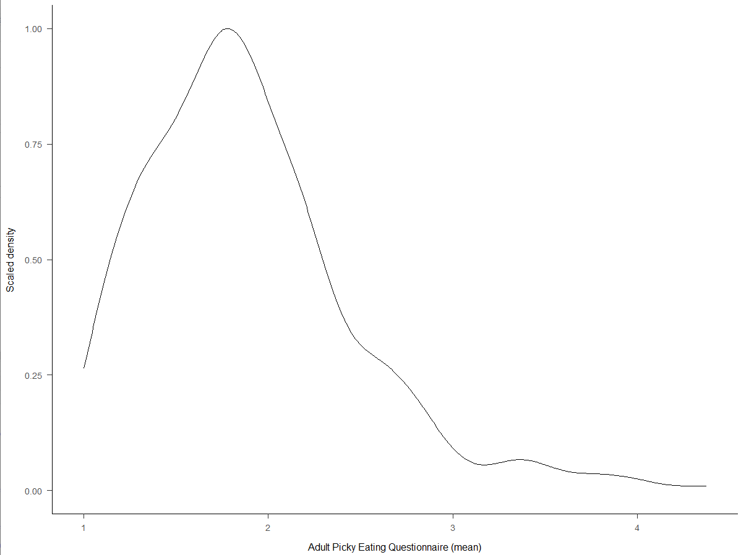
Note. The distribution of the mean of the Adult Picky Eating Questionnaire is severely positively skewed.

Figure S2. Density Plot of the Mean of the Adult Picky Eating Questionnaire, Food Variety Subscale in Prestudy.
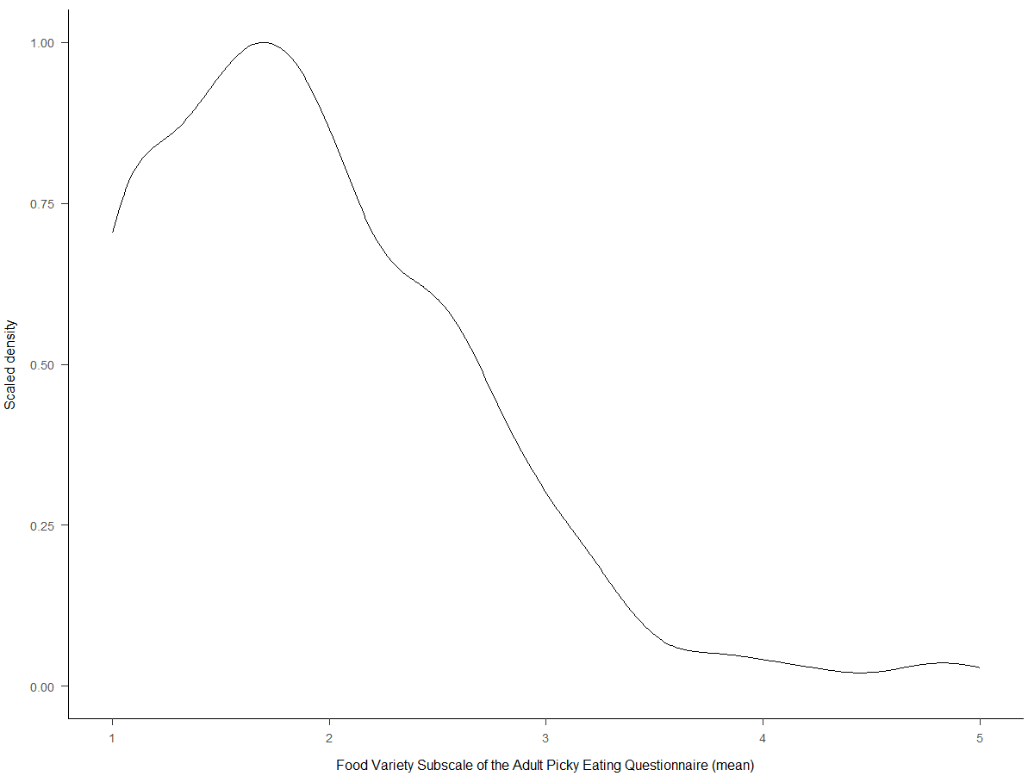
Note. The distribution of the mean of the Food Variety subscale of the Adult Picky Eating Questionnaire is severely positively skewed.

Figure S3. Density Plot of the Mean of the Adult Picky Eating Questionnaire, Taste Aversion Subscale in Prestudy.
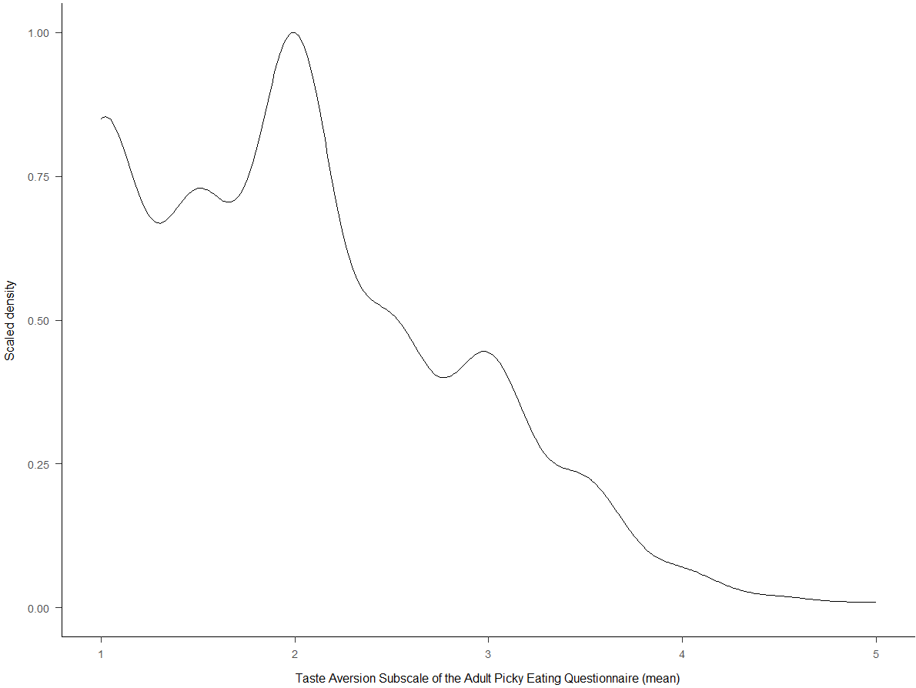
Note. The distribution of the mean of the Taste Aversion subscale of the Adult Picky Eating Questionnaire is severely positively skewed.

Figure S4. Density Plot of the Sum Score of the Nine-Item ARFID Screen, Picky Eating Subscale in Prestudy.
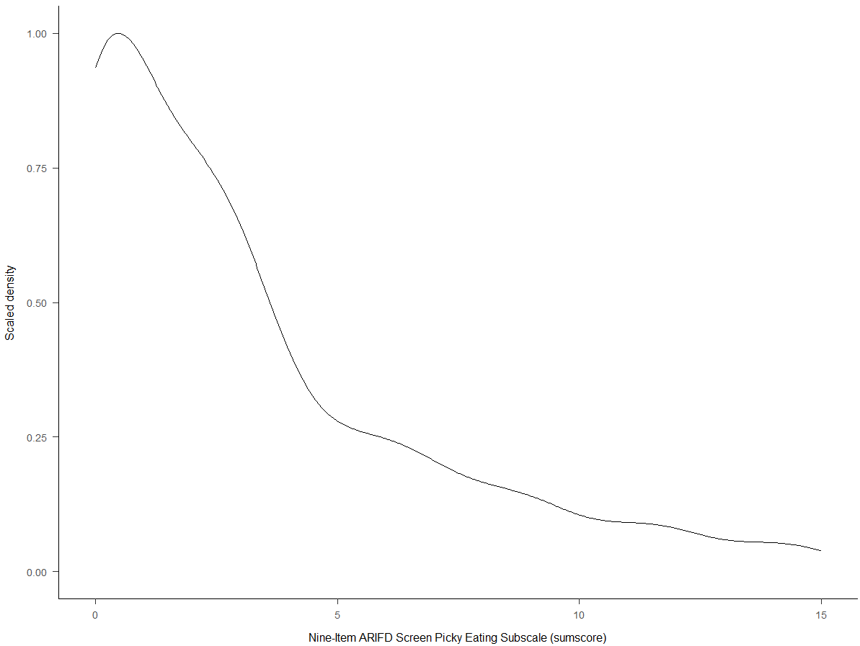
Note. The distribution of the sum score of the Picky Eating subscale of the Nine-Item ARFID Screen is severely positively skewed.
Figure S5. Density Plot of the Mean of the Food Neophobia Scale in Prestudy.
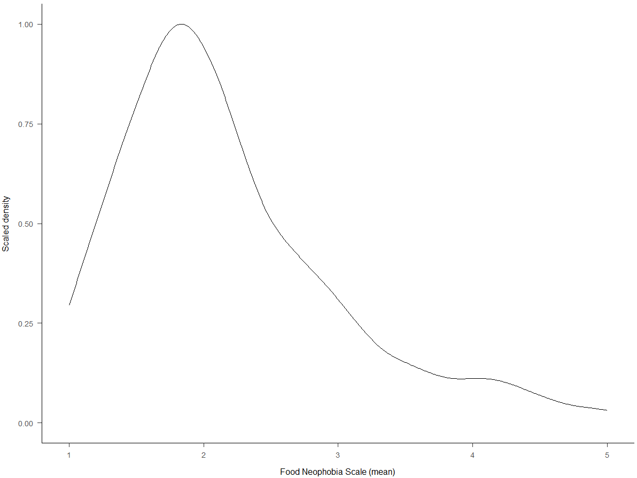
Note. The distribution of the mean of the Food Neophobia Scale is severely positively skewed.

Figure S6. Density Plot of the Mean Liking Score of the Food Preference Questionnaire in Prestudy.
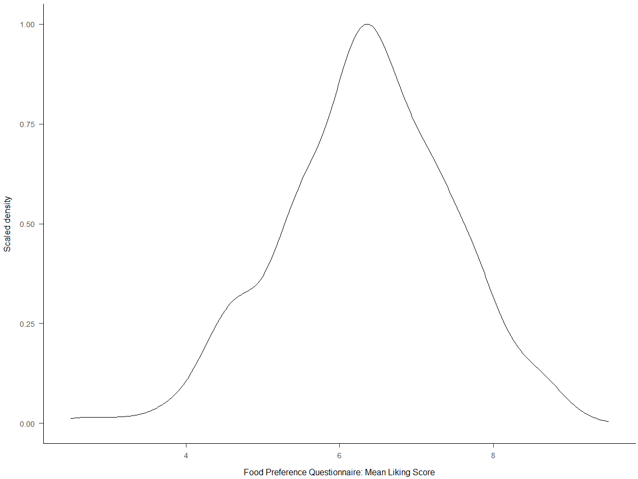
Note. The distribution of the mean liking score of the Food Preference Questionnaire is not severely skewed.
Figure S7. Density Plot of the Low Proportion Score of the Food Preference Questionnaire in Prestudy.
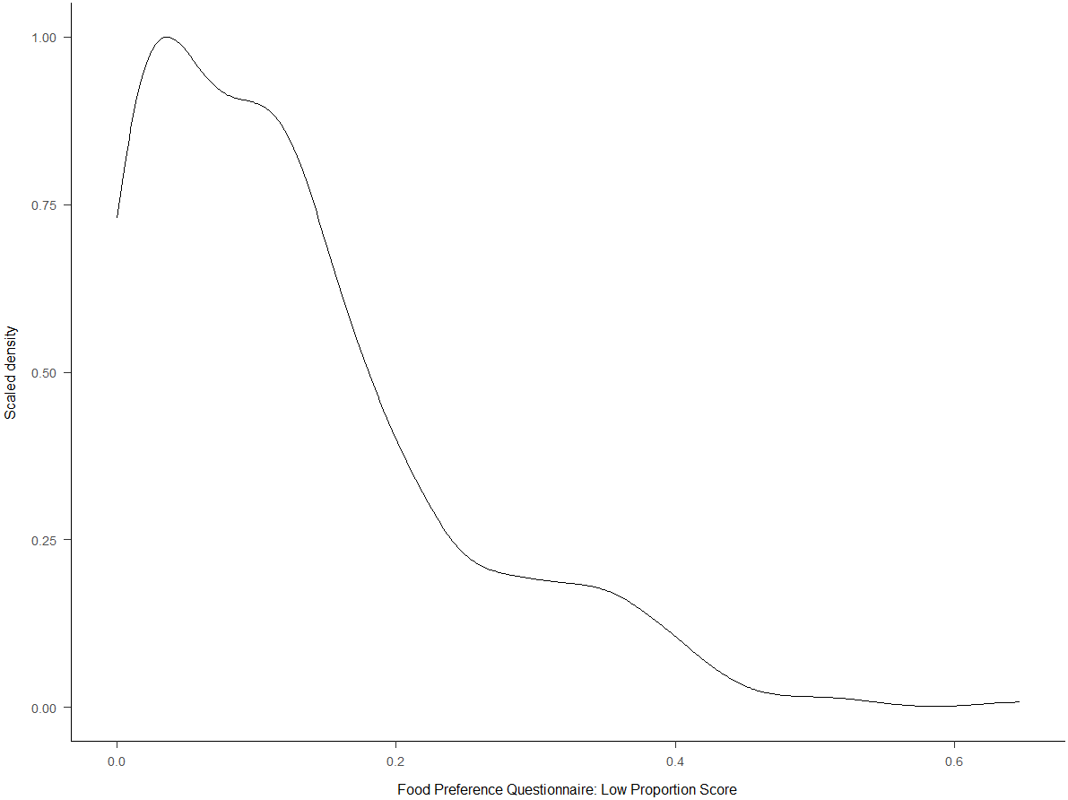
Note. The distribution of the low proportion score of the Food Preference Questionnaire is severely positively skewed.

Figure S8. Density Plot of the Sour/Bitter Liking Score of the Food Preference Questionnaire in Prestudy.
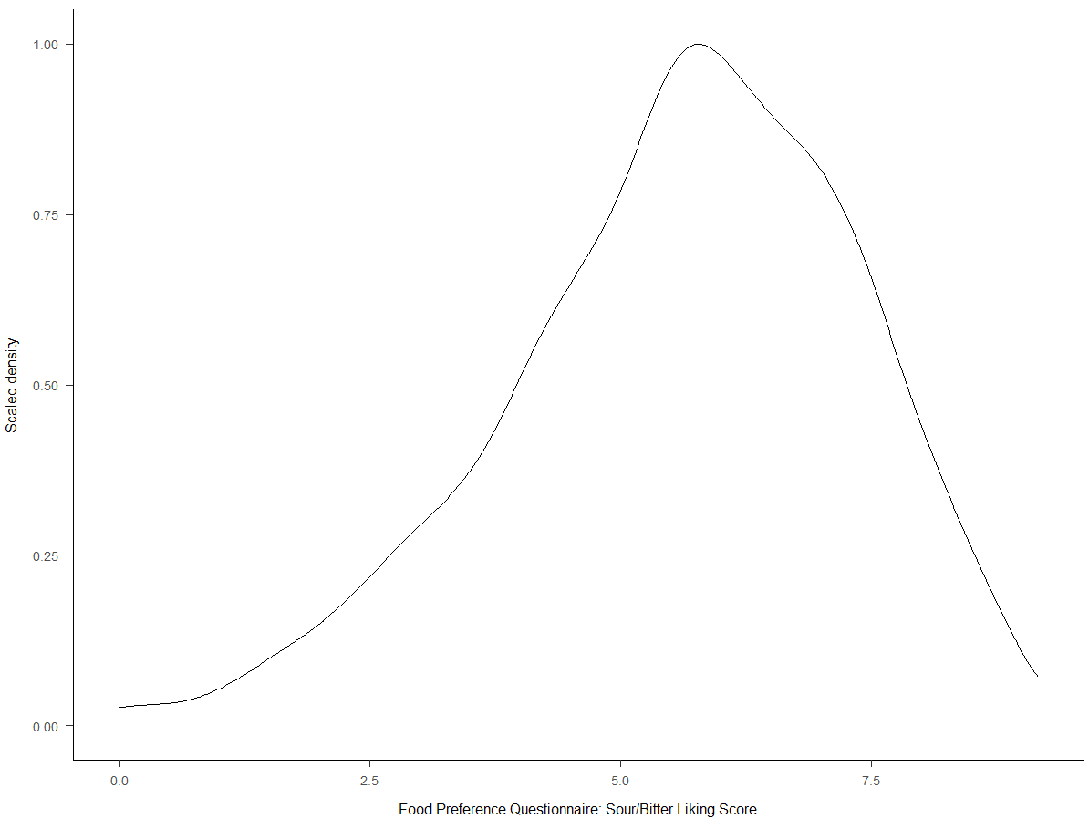
Note. The distribution of the sour/bitter liking score of the Food Preference Questionnaire is negatively skewed.
Figure S9. Density Plot of the Never Tried Score of the Food Preference Questionnaire in Prestudy.
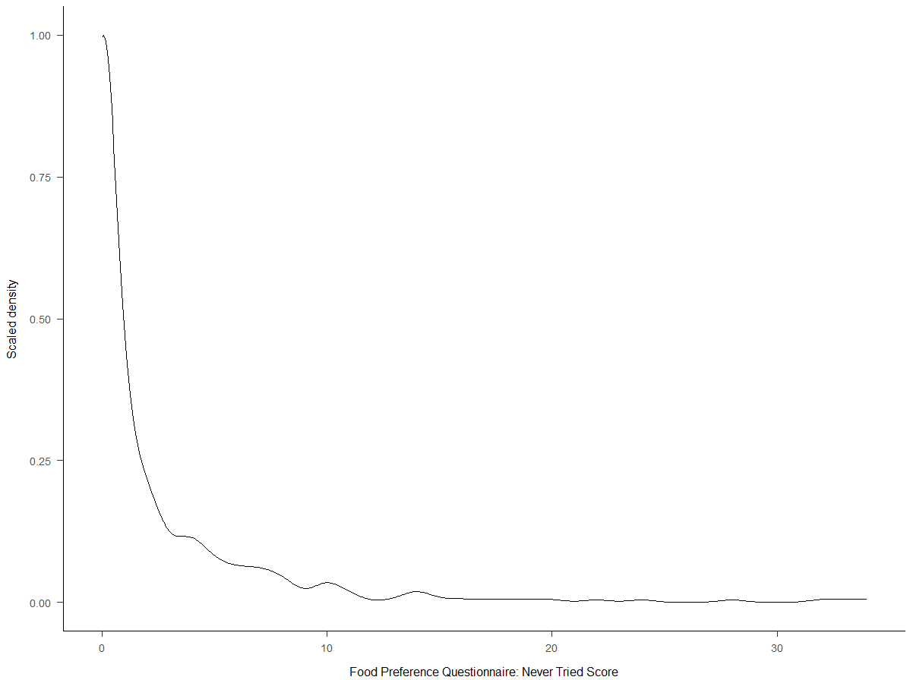
Note. The distribution of the never tried score of the Food Preference Questionnaire is severely positively skewed.

Figure S10. Density Plot of the Disgust Score of the Avoidance of Food Groups Questionnaire in Prestudy.
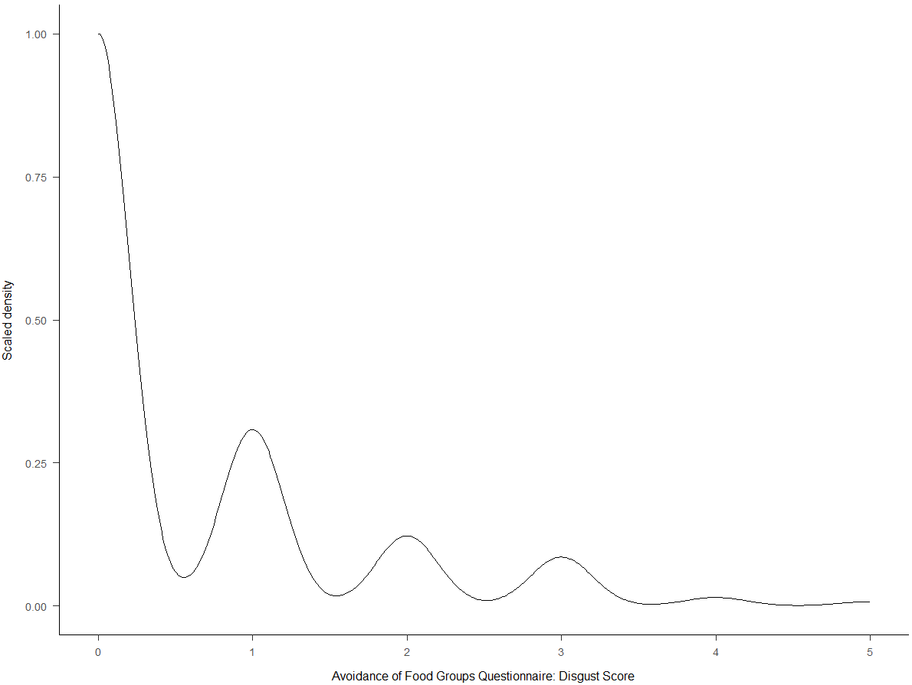
Note. The distribution of the disgust score of the Avoidance of Food Groups Questionnaire is severely positively skewed.
Figure S11. Density Plot of the Mean Liking Score of the Food Preference Questionnaire in Main Study
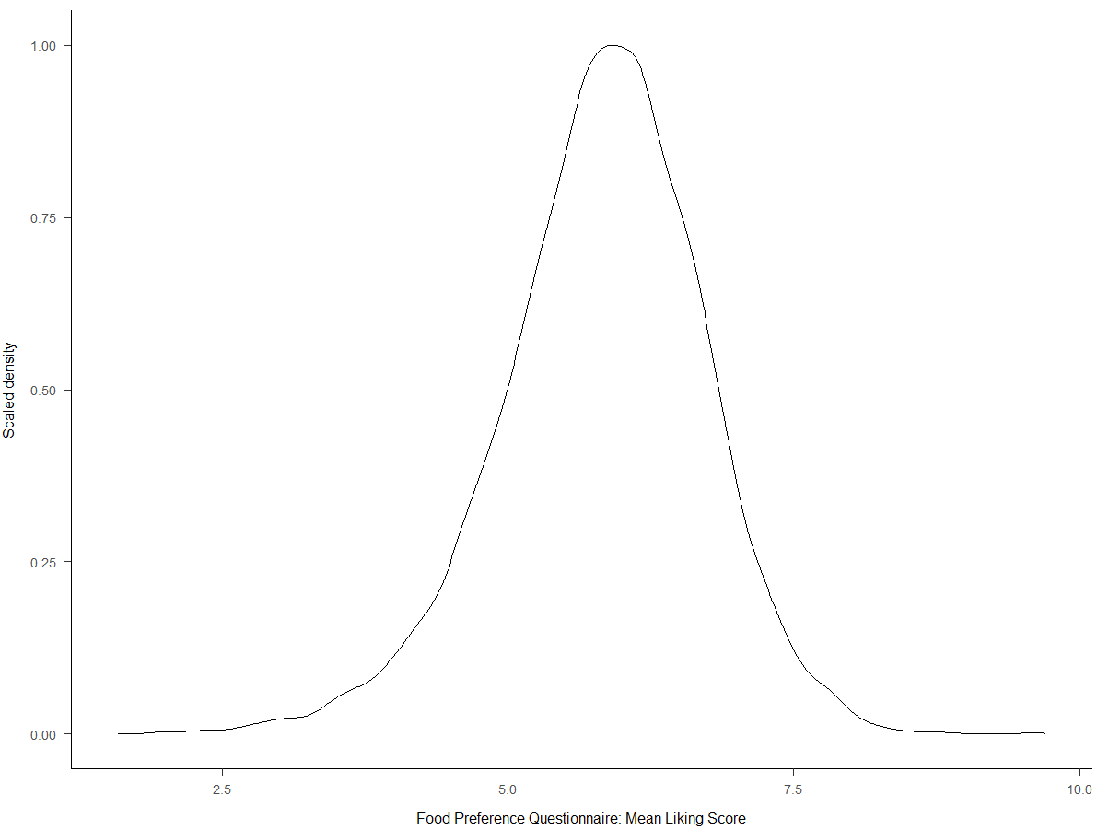
Note. The distribution of the mean liking score of the Food Preference Questionnaire is not severely skewed.

